**Super Premier League Management System**



**Coordinators Name: Parnia Samimi**

**Module Code: CMP71214**

**Project Members:**

S17109723: Auwais Rafiq

20173933: Muzahir Hussain

Contents

1. Project Description 4

2. Database Analysis 4

3. Business Rules 5

4. Entities/Attributes 6

ERD Mapping 7

Mapping 1:1 Relationships 7

Mapping 1: N Relationships 12

Mapping N: N Relationships 15

5. ERD Diagram: Planning Design. 17

Final ERD 17

Normalization: 18

Team: 18

Player: 18

Contract: 18

Managers: 19

Staff: 19

Team_Sponsor: 19

Player_Sponsor: 20

Player_Attribute: 20

GK_Attributes: 20

PL_Attributes: 21

Stadium: 21

Achievement: 21

Query Optimisation Using indexes: 22

Example 1: 22

Example 2: 23

Database Implementation 25

Create Scripts: 25

Adding Foreign Keys: 29

Insert into Scripts: 32

Created Tables 61

SQL Queries: 62

Query 1: Select players from specific team (Manchester City) whose contracts would be expiring this year. (This query would be useful for player contract renewals) 62

Query 2: Select players who are strikers, and their age is above 30. (This query would be useful to check if a club needs to buy a new player) 62

Query 3: Get Player_name, age and passing_accuracy that plays in midfield for specific team. (This query would be useful to get insights on players attributes) 62

Query 4: Get team_name with the most PL wins (in this available record) 62

Query 5: Get Manager contract that will expire within next year. (This query would be useful for manager contract renewals) 63

Query 6: Get the total of medical and coaches staff in specific team (Chelsea) (This query would be useful to reinforce the staff team that has less members 63

Query 7: Get PL and FA cup winners from a specific year (2014) 63

Query 8: Get all sponsors for single specific team (Manchester United) 63

Query 9: Get players from specific team (Liverpool) with wages > 150000/week (This query would be useful to get to know teams wages distribution) 64

Query 10: Get list of players with no sponsors 64

Conclusion: 64

References: 64

# Project Description

The aim of the project is to build a relational database for the top clubs in the Premier League. The premier league is the pinnacle of English football league system. It’s a private company fully owned by its 20 clubs who make up their position in the league with the system of promotion and relegation within the English Football league. However, this database will be created for the top five clubs in the premier league of all time. All different data types can be stored in databases including continuous or categorical data. This data can include performance data from different seasons, preseason, and competitions (Vincent, J., Stergiou. P. and Katz, L. 2009). This data can be used to decide whether a player is performing to a high standard or whether they are drifting. Teams use this type of data when deciding to purchase a certain player. The database can also show when each of the five teams had their period of success. Indexing will be used in our project this will efficiently search data from the database using minimal time.

# Database Analysis

The project will be about the football league database management system, focusing on the top English league the Premier League. The Database will have entities such as: **Football Teams, Mangers, Stadiums, Stadium Capacity, Coaches, Managers, Sponsors, Players, Player Details, Player Contracts, Player Attributes, Skills, Club Presidents/Owners and Medics and Doctors.**

The database will consist of 12 tables: The premier league contains 5 teams: **Team** (**TeamID, Name, City, Owner, Captain, Manager, Stadium**), **Players** of teams, (**PlayerID, Name, DoB, Age, Position, JID, Nationality, TeamID, AttributeID, ContractID**). Each team has a **Manager**: (**ManagerID, Name, DoB, Age, Contract**). Each Team has its own **Stadium**: (**StadiumID, Name, Capacity**). The Premier league has many **sponsors** that represent the brand which has helped its growth and each player has a sponsor. **Player Sponsor** (**SponsorID, PlayerID, Name**) **TeamSponsor** (**SponsorID, TeamID, Name)**. Each team in fighting to build its own legacy with their **achievements**. (**Title_Year, PLWinners, FAWinners**). All teams have **staff** who have many roles around the team (**StaffID, StaffMemberName, StaffType, TeamID, ContractID)**. **Coaches** have a big say on teams whether they are set-piece coaches or medical staff. Importance of **physios/doctors** in football is very important, during the recent Euro 2020 Denmark played Finland, a stoppage of play occurred around the 40th min where footballer Christian Eriksen suffered cardiac arrest. Had there been any delay in his treatment the footballer could have not been with us today. With ever growing technology footballers are judged on **statistics/Player Attributes (AttributeID, PlayerID),** Teams use this data when purchasing or offloading players and renewing contracts. (**PL_Attribute_ID, AttributeID, Speed, BallCtrl, Dribbling, PassAcc, Posc) Goalkeepers have their own attributes (GK_Attribute_ID, AttributeID, GKBallHandling, GKReflexes, Leadership, Shooting)**. **Contracts** are very important whether that is a player’s contract or manager’s contract. Without a contract a footballer or manager cannot be present for a team. (**ContractID, ContractExpiry, Wage**).

# Business Rules

Manager to Team

Manager manages football team. Connection 1:1

Player to Team

Player plays for team managed by manager. Connection 1: N

Team to Stadium

Each Football team has a stadium. Connection 1:1

Team to Achievements

Team has Achievements. Connection 1: N

Team to Staff

Team consists of Staff. Connection 1: N

Manger to Contract

Manager has Contract. Connection 1:1

Player to Contract

Player has Contract. Connection 1:1

Team Sponsor to team

Team Sponsor Sponsors Team. Connection N: N

Sponsor to Player Sponsor

Sponsor Sponsors Player. Connection N: N

# Entities/Attributes

|  |
| --- |
| GK Attributes |
| GK_Attribute_ID PK |
| AttributeID |
| GKBallHandling |
| GKReflexes |
| Leadership |
| Shooting |

|  |
| --- |
| Contracts |
| ContractID PK |
| Contract_Expration |
| Wage |

|  |
| --- |
| PL_ Attributes |
| PL_Attribute_ID PK |
| AttributeID |
| Speed |
| Ball Control |
| Dribbling |
| Passing Accuracy |
| Positioning |

|  |
| --- |
| Team |
| TeamID |
| Name PK |
| City |
| Owner |
| Captain_ID |
| ManagerID |
| StadiumID |

|  |
| --- |
| Manager |
| ManagerID PK |
| Name |
| DoB |
| Age |
| ContractID |

|  |
| --- |
| Players |
| PlayerID PK |
| Name |
| DoB |
| Age |
| Position |
| JID |
| Nationality |
| Team_ID |
| Attribute_ID |
| Contract_ID |

|  |
| --- |
| Player Attribute |
| Attribute ID PK |
| PlayerID |

|  |
| --- |
| Staff |
| StaffID PK |
| Staff Member Name |
| Staff Type |
| TeamID |
| ContractID |

|  |
| --- |
| Achievements |
| Title_Year PK |
| Fa Winner |
| PL Winner |

|  |
| --- |
| TeamSponsor |
| SponsorID PK |
| TeamID |
| SponsorName |

|  |
| --- |
| PlayerSponsor |
| SponsorID PK |
| TeamID |
| SponsorName |

# ERD Mapping

### Mapping 1:1 Relationships

**1**

**Manages**

TEAM

MANAGER

**1**

**Manager**

|  |  |  |  |  |
| --- | --- | --- | --- | --- |
| **Manager_ID** | **Manager_Name** | **Manager_dob** | **Manager_Age** | **Contract_ID** |
| 1 | Thomas Tuchel | 29/08/1973 | 47 | 1 |
| 2 | Ole Gunnar Solskjær | 26/02/1973 | 48 | 2 |
| 3 | Pep Guardiola | 18/01/1971 | 50 | 3 |
| 4 | Jürgen Klopp | 16/06/1967 | 54 | 4 |
| 5 | Mikel Arteta | 26/03/1982 | 39 | 5 |

**Team**

|  |  |  |  |  |  |  |
| --- | --- | --- | --- | --- | --- | --- |
| **Team_ID** | **Team_Name** | **City** | **President** | **Captain_ID** | **Manager_ID** | **Stadium_ID** |
| 1 | Chelsea | London | Roman Arkadyevich Abramovich | 1 | 1 | 1 |
| 2 | Man United | Manchester | Ed Woodward | 2 | 2 | 2 |
| 3 | Man City | Manchester | Ferran Soriano | 3 | 3 | 3 |
| 4 | Liverpool | Liverpool | Michael S. Gordon | 4 | 4 | 4 |
| 5 | Arsenal | London | Stan Kroenke | 5 | 5 | 5 |

MANAGER

CONTRACT

**1**

**1**

**Has**

**Manager**

|  |  |  |  |  |
| --- | --- | --- | --- | --- |
| **Manager_ID** | **Manager_Name** | **Manager_dob** | **Manager_Age** | **Contract_ID** |
| 1 | Thomas Tuchel | 29/08/1973 | 47 | 1 |
| 2 | Ole Gunnar Solskjær | 26/02/1973 | 48 | 2 |
| 3 | Pep Guardiola | 18/01/1971 | 50 | 3 |
| 4 | Jürgen Klopp | 16/06/1967 | 54 | 4 |
| 5 | Mikel Arteta | 26/03/1982 | 39 | 5 |

|  |  |  |
| --- | --- | --- |
| **Contract_ID** | **Contract_expiration** | **Wage** |
| 1 | 01/12/2022 | 75000 |
| 2 | 01/12/2023 | 160000 |
| 3 | 01/12/2021 | 417500 |
| 4 | 01/12/2024 | 313500 |
| 5 | 01/12/2024 | 105000 |
| 6 | 01/12/2024 | 145000 |
| 7 | 01/12/2025 | 190000 |
| 8 | 01/12/2022 | 150000 |
| 9 | 01/12/2027 | 100000 |
| 10 | 01/12/2024 | 250000 |
| 11 | 01/12/2026 | 120000 |
| 12 | 01/06/2022 | 120000 |
| 13 | 01/06/2025 | 117000 |
| 14 | 01/12/2026 | 120000 |
| 15 | 01/12/2026 | 220000 |
| 16 | 01/12/2026 | 120000 |
| 17 | 01/12/2024 | 120000 |
| 18 | 01/12/2023 | 130000 |
| 19 | 01/12/2026 | 120000 |
| 20 | 01/12/2025 | 170000 |
| 21 | 01/12/2026 | 190000 |
| 22 | 01/12/2026 | 190000 |
| 23 | 01/12/2026 | 120000 |
| 24 | 01/12/2026 | 200000 |
| 25 | 01/12/2026 | 170000 |
| 26 | 01/12/2026 | 170000 |
| 27 | 01/12/2026 | 120000 |
| 28 | 01/12/2026 | 130000 |
| 29 | 01/12/2026 | 110000 |
| 30 | 01/12/2026 | 110000 |
| 31 | 01/12/2026 | 120000 |
| 32 | 01/12/2022 | 27000 |
| 33 | 01/12/2021 | 22000 |
| 34 | 01/12/2021 | 22000 |
| 35 | 01/12/2023 | 50000 |
| 36 | 01/06/2023 | 43000 |
| 37 | 01/01/2023 | 27000 |
| 38 | 01/01/2023 | 32000 |
| 39 | 01/06/2023 | 23000 |
| 40 | 01/01/2023 | 26000 |
| 41 | 01/04/2022 | 31000 |
| 42 | 01/12/2021 | 55000 |
| 43 | 01/09/2023 | 37000 |
| 44 | 01/01/2024 | 31000 |
| 45 | 01/11/2025 | 55000 |
| 46 | 01/12/2026 | 37000 |

Contract

**1**

**1**

STADIUM

TEAM

**Has A**

**Team**

|  |  |  |  |  |  |  |
| --- | --- | --- | --- | --- | --- | --- |
| **Team_ID** | **Team_Name** | **City** | **President** | **Captain_ID** | **Manager_ID** | **Stadium_ID** |
| 1 | Chelsea | London | Roman Arkadyevich Abramovich | 1 | 1 | 1 |
| 2 | Man United | Manchester | Ed Woodward | 2 | 2 | 2 |
| 3 | Man City | Manchester | Ferran Soriano | 3 | 3 | 3 |
| 4 | Liverpool | Liverpool | Michael S. Gordon | 4 | 4 | 4 |
| 5 | Arsenal | London | Stan Kroenke | 5 | 5 | 5 |

**Stadium**

|  |  |  |
| --- | --- | --- |
| **Stadium_ID** | **Stadium_Name** | **Stadium_Capacity** |
| 1 | Stamford Bridge | 41837 |
| 2 | Old Trafford | 74140 |
| 3 | Etihad Stadium | 55017 |
| 4 | Anfield | 53394 |
| 5 | Emirates Stadium | 60260 |

**Has**

**1**

**1**

CONTRACT

PLAYER

**Player**

|  |  |  |  |  |  |  |  |  |  |
| --- | --- | --- | --- | --- | --- | --- | --- | --- | --- |
| Player_id | Player_ name, | Player_dob | Player_age | Playing_position | player_ Jersey No | player_ nationality | Team_ID | Attribute_ID | Contract_ID |
| 1 | Cesar Azpilicueta | 28/08/1989 | 31 | Centre- back | 28 | Spanish | 1 | 1 | 6 |
| 2 | Harry Maguire | 05/03/1993 | 28 | Centre back | 6 | English | 2 | 2 | 7 |
| 3 | Fernandinho | 04/04/1985 | 36 | Midfielder | 25 | Brazilian | 3 | 3 | 8 |
| 4 | Jordan Henderson | 17/06/1990 | 31 | Midfielder | 14 | English | 4 | 4 | 9 |
| 5 | Pierre- Emrick Aubameyang | 18/06/1989 | 32 | Striker | 14 | French | 5 | 5 | 10 |
| 6 | Ngolo Kante | 29/03/1991 | 30 | Central midfielder | 13 | French | 1 | 6 | 11 |
| 7 | Thiago Silva | 22/09/1984 | 36 | Centre back | 6 | Brazilian | 1 | 7 | 12 |
| 8 | Timo Werner | 06/03/1996 | 25 | Forward | 1 | German | 1 | 8 | 13 |
| 9 | Kepa Arrizabalaga | 03/10/1994 | 26 | Goalkeeper | 1 | Spanish | 1 | 9 | 14 |
| 10 | Paul Pogba | 15/03/1993 | 28 | Central midfielder | 6 | French | 2 | 10 | 15 |
| 11 | Marcus Rashford | 01/12/2026 | 23 | Forward | 11 | English | 2 | 11 | 16 |
| 12 | Anthony Martial | 05/12/1995 | 25 | Forward | 9 | French | 2 | 12 | 17 |
| 13 | Edinson Cavani | 14/02/1987 | 34 | Forward | 7 | Uruguayan | 2 | 13 | 18 |
| 14 | David de Gea | 07/11/1990 | 30 | GoalKeeper | 1 | Spanish | 2 | 14 | 19 |
| 15 | Raheem Sterling | 08/12/1994 | 26 | Winger | 10 | English | 3 | 15 | 20 |
| 16 | Kevin De Bruyne | 28/06/1991 | 30 | Midfielder | 17 | Belgium | 3 | 16 | 21 |
| 17 | Riyad Mahrez | 21/02/1991 | 30 | Midfielder | 26 | Algerian | 3 | 17 | 22 |
| 18 | Ederson Santana de Moares | 17/08/1993 | 27 | Goalkeeper | 1 | Brazilian | 3 | 18 | 23 |
| 19 | Mo Salah | 15/06/1992 | 29 | forward | 11 | Egyptian | 4 | 19 | 24 |
| 20 | Virgil Van Djik | 08/07/1991 | 30 | Centre back | 4 | Netherlands | 4 | 20 | 25 |
| 21 | Sadio Mane | 10/04/1992 | 29 | Winger | 10 | Senegal | 4 | 21 | 26 |
| 22 | Alisson Becker | 02/10/1992 | 28 | goalkeeper | 1 | Brazilian | 4 | 22 | 27 |
| 23 | Ben White | 08/10/1997 | 23 | Centre back | 4 | English | 5 | 23 | 28 |
| 24 | Bukayo Saka | 05/09/2001 | 19 | Winger | 7 | English | 5 | 24 | 29 |
| 25 | Granit Xhaka | 27/09/1992 | 28 | midfielder | 34 | Switzerland | 5 | 25 | 30 |

**Contract**

|  |  |  |
| --- | --- | --- |
| **Contract_ID** | **Contract_expiration** | **Wage** |
| 1 | 01/12/2022 | 75000 |
| 2 | 01/12/2023 | 160000 |
| 3 | 01/12/2021 | 417500 |
| 4 | 01/12/2024 | 313500 |
| 5 | 01/12/2024 | 105000 |
| 6 | 01/12/2024 | 145000 |
| 7 | 01/12/2025 | 190000 |
| 8 | 01/12/2022 | 150000 |
| 9 | 01/12/2027 | 100000 |
| 10 | 01/12/2024 | 250000 |
| 11 | 01/12/2026 | 120000 |
| 12 | 01/06/2022 | 120000 |
| 13 | 01/06/2025 | 117000 |
| 14 | 01/12/2026 | 120000 |
| 15 | 01/12/2026 | 220000 |
| 16 | 01/12/2026 | 120000 |
| 17 | 01/12/2024 | 120000 |
| 18 | 01/12/2023 | 130000 |
| 19 | 01/12/2026 | 120000 |
| 20 | 01/12/2025 | 170000 |
| 21 | 01/12/2026 | 190000 |
| 22 | 01/12/2026 | 190000 |
| 23 | 01/12/2026 | 120000 |
| 24 | 01/12/2026 | 200000 |
| 25 | 01/12/2026 | 170000 |
| 26 | 01/12/2026 | 170000 |
| 27 | 01/12/2026 | 120000 |
| 28 | 01/12/2026 | 130000 |
| 29 | 01/12/2026 | 110000 |
| 30 | 01/12/2026 | 110000 |
| 31 | 01/12/2026 | 120000 |
| 32 | 01/12/2022 | 27000 |
| 33 | 01/12/2021 | 22000 |
| 34 | 01/12/2021 | 22000 |
| 35 | 01/12/2023 | 50000 |
| 36 | 01/06/2023 | 43000 |
| 37 | 01/01/2023 | 27000 |
| 38 | 01/01/2023 | 32000 |
| 39 | 01/06/2023 | 23000 |
| 40 | 01/01/2023 | 26000 |
| 41 | 01/04/2022 | 31000 |
| 42 | 01/12/2021 | 55000 |
| 43 | 01/09/2023 | 37000 |
| 44 | 01/01/2024 | 31000 |
| 45 | 01/11/2025 | 55000 |
| 46 | 01/12/2026 | 37000 |

### Mapping 1: N Relationships

**Plays For**

**1**

**N**

TEAM

PLAYER

**Player**

|  |  |  |  |  |  |  |  |  |  |
| --- | --- | --- | --- | --- | --- | --- | --- | --- | --- |
| Player_id | Player_ name, | Player_dob | Player_age | Playing_position | player_ Jersey No | player_ nationality | Team_ID | Attribute_ID | Contract_ID |
| 1 | Cesar Azpilicueta | 28/08/1989 | 31 | Centre- back | 28 | Spanish | 1 | 1 | 6 |
| 2 | Harry Maguire | 05/03/1993 | 28 | Centre back | 6 | English | 2 | 2 | 7 |
| 3 | Fernandinho | 04/04/1985 | 36 | Midfielder | 25 | Brazilian | 3 | 3 | 8 |
| 4 | Jordan Henderson | 17/06/1990 | 31 | Midfielder | 14 | English | 4 | 4 | 9 |
| 5 | Pierre- Emrick Aubameyang | 18/06/1989 | 32 | Striker | 14 | French | 5 | 5 | 10 |
| 6 | Ngolo Kante | 29/03/1991 | 30 | Central midfielder | 13 | French | 1 | 6 | 11 |
| 7 | Thiago Silva | 22/09/1984 | 36 | Centre back | 6 | Brazilian | 1 | 7 | 12 |
| 8 | Timo Werner | 06/03/1996 | 25 | Forward | 1 | German | 1 | 8 | 13 |
| 9 | Kepa Arrizabalaga | 03/10/1994 | 26 | Goalkeeper | 1 | Spanish | 1 | 9 | 14 |
| 10 | Paul Pogba | 15/03/1993 | 28 | Central midfielder | 6 | French | 2 | 10 | 15 |
| 11 | Marcus Rashford | 01/12/2026 | 23 | Forward | 11 | English | 2 | 11 | 16 |
| 12 | Anthony Martial | 05/12/1995 | 25 | Forward | 9 | French | 2 | 12 | 17 |
| 13 | Edinson Cavani | 14/02/1987 | 34 | Forward | 7 | Uruguayan | 2 | 13 | 18 |
| 14 | David de Gea | 07/11/1990 | 30 | GoalKeeper | 1 | Spanish | 2 | 14 | 19 |
| 15 | Raheem Sterling | 08/12/1994 | 26 | Winger | 10 | English | 3 | 15 | 20 |
| 16 | Kevin De Bruyne | 28/06/1991 | 30 | Midfielder | 17 | Belgium | 3 | 16 | 21 |
| 17 | Riyad Mahrez | 21/02/1991 | 30 | Midfielder | 26 | Algerian | 3 | 17 | 22 |
| 18 | Ederson Santana de Moares | 17/08/1993 | 27 | Goalkeeper | 1 | Brazilian | 3 | 18 | 23 |
| 19 | Mo Salah | 15/06/1992 | 29 | forward | 11 | Egyptian | 4 | 19 | 24 |
| 20 | Virgil Van Djik | 08/07/1991 | 30 | Centre back | 4 | Netherlands | 4 | 20 | 25 |
| 21 | Sadio Mane | 10/04/1992 | 29 | Winger | 10 | Senegal | 4 | 21 | 26 |
| 22 | Alisson Becker | 02/10/1992 | 28 | goalkeeper | 1 | Brazilian | 4 | 22 | 27 |
| 23 | Ben White | 08/10/1997 | 23 | Centre back | 4 | English | 5 | 23 | 28 |
| 24 | Bukayo Saka | 05/09/2001 | 19 | Winger | 7 | English | 5 | 24 | 29 |
| 25 | Granit Xhaka | 27/09/1992 | 28 | midfielder | 34 | Switzerland | 5 | 25 | 30 |

**Team**

|  |  |  |  |  |  |  |
| --- | --- | --- | --- | --- | --- | --- |
| **Team_ID** | **Team_Name** | **City** | **President** | **Captain_ID** | **Manager_ID** | **Stadium_ID** |
| 1 | Chelsea | London | Roman Arkadyevich Abramovich | 1 | 1 | 1 |
| 2 | Man United | Manchester | Ed Woodward | 2 | 2 | 2 |
| 3 | Man City | Manchester | Ferran Soriano | 3 | 3 | 3 |
| 4 | Liverpool | Liverpool | Michael S. Gordon | 4 | 4 | 4 |
| 5 | Arsenal | London | Stan Kroenke | 5 | 5 | 5 |

**Has**

**1**

**N**

ACHIEVEMENTS

TEAM

**Team**

|  |  |  |  |  |  |  |
| --- | --- | --- | --- | --- | --- | --- |
| **Team_ID** | **Team_Name** | **City** | **President** | **Captain_ID** | **Manager_ID** | **Stadium_ID** |
| 1 | Chelsea | London | Roman Arkadyevich Abramovich | 1 | 1 | 1 |
| 2 | Man United | Manchester | Ed Woodward | 2 | 2 | 2 |
| 3 | Man City | Manchester | Ferran Soriano | 3 | 3 | 3 |
| 4 | Liverpool | Liverpool | Michael S. Gordon | 4 | 4 | 4 |
| 5 | Arsenal | London | Stan Kroenke | 5 | 5 | 5 |

**Achievements**

|  |  |  |
| --- | --- | --- |
| **Title_year** | **Pl_winner** | **Fa_winner** |
| 2015 | 1 | 5 |
| 2014 | 3 | 5 |
| 2012 | 3 | 1 |
| 2011 | 2 | 3 |
| 2010 | 1 | 1 |
| 2009 | 2 | 1 |
| 2007 | 2 | 1 |
| 2006 | 1 | 4 |

**Consists Of**

**1**

**N**

STAFF

TEAM

**Team**

|  |  |  |  |  |  |  |
| --- | --- | --- | --- | --- | --- | --- |
| **Team_ID** | **Team_Name** | **City** | **President** | **Captain_ID** | **Manager_ID** | **Stadium_ID** |
| 1 | Chelsea | London | Roman Arkadyevich Abramovich | 1 | 1 | 1 |
| 2 | Man United | Manchester | Ed Woodward | 2 | 2 | 2 |
| 3 | Man City | Manchester | Ferran Soriano | 3 | 3 | 3 |
| 4 | Liverpool | Liverpool | Michael S. Gordon | 4 | 4 | 4 |
| 5 | Arsenal | London | Stan Kroenke | 5 | 5 | 5 |

**Staff**

|  |  |  |  |  |
| --- | --- | --- | --- | --- |
| **Staff_ID** | **Staff_Member_Name** | **Staff_Type** | **Team_ID** | **Contract_ID** |
| 1 | Eva Carneiro | Medical | 1 | 32 |
| 2 | Dimitris Kalogianndis | Medical | 1 | 33 |
| 3 | Jason Palmer | Medical | 1 | 34 |
| 4 | Jody Morris | Coach | 1 | 35 |
| 5 | Rod Thornley | Medical | 2 | 36 |
| 6 | Jos Van Dijk | Medical | 2 | 37 |
| 7 | Eric Ramsay | Coach | 2 | 38 |
| 8 | Eduardi Mauri | Medical | 3 | 39 |
| 9 | Steve Sparks | Medical | 3 | 40 |
| 10 | Andrew Massey | Medical | 4 | 41 |
| 11 | Dr Jim Moxon | Medical | 4 | 42 |
| 12 | Pepijin Lijnders | Coach | 4 | 43 |
| 13 | Jordan Reece | Medical | 5 | 44 |
| 14 | Richard Allison | Medical | 5 | 45 |
| 15 | Albert Stuivenburg | Coach | 5 | 46 |

### Mapping N: N Relationships

**N**

**N**

TEAM

TEAM SPONSOR

**Sponsors**

**Team Sponsor**

|  |  |  |
| --- | --- | --- |
| **Sponsor_ID** | **Team_ID** | **Sponsor_Name** |
| 1 | 1 | Three |
| 2 | 1 | Nike |
| 3 | 2 | Adidas |
| 4 | 2 | Chevrolet |
| 5 | 2 | DHL |
| 6 | 3 | Etihad Airways |
| 7 | 3 | Puma |
| 8 | 3 | Nissan |
| 9 | 4 | Standard Chartered |
| 10 | 4 | Nike |
| 11 | 5 | Emirates |
| 12 | 5 | Adidas |

**Team**

|  |  |  |  |  |  |  |
| --- | --- | --- | --- | --- | --- | --- |
| **Team_ID** | **Team_Name** | **City** | **President** | **Captain_ID** | **Manager_ID** | **Stadium_ID** |
| 1 | Chelsea | London | Roman Arkadyevich Abramovich | 1 | 1 | 1 |
| 2 | Man United | Manchester | Ed Woodward | 2 | 2 | 2 |
| 3 | Man City | Manchester | Ferran Soriano | 3 | 3 | 3 |
| 4 | Liverpool | Liverpool | Michael S. Gordon | 4 | 4 | 4 |
| 5 | Arsenal | London | Stan Kroenke | 5 | 5 | 5 |

**N**

**N**

TEAM

PLAYER SPONSOR

**Sponsors**

**Player Sponsor**

|  |  |  |
| --- | --- | --- |
| **Sponsor_ID** | **Player_ID** | **Sponsor_Name** |
| 1 | 2 | Nike |
| 2 | 2 | Puma |
| 3 | 3 | Puma |
| 4 | 4 | MaxiNutrition |
| 5 | 5 | Nike |
| 6 | 6 | Adidas |
| 7 | 10 | Adidas |
| 8 | 10 | PepsiCo |
| 9 | 10 | TCL |
| 10 | 11 | Nike |
| 11 | 14 | Adidas |
| 12 | 15 | New Balance |
| 13 | 16 | EA Sports |
| 14 | 17 | Nike |
| 15 | 19 | Addidas |
| 16 | 20 | EA Sports |
| 17 | 20 | Nike |
| 18 | 21 | New Balance |
| 19 | 22 | Nike |
| 20 | 25 | Under Armour |

**Team**

|  |  |  |  |  |  |  |
| --- | --- | --- | --- | --- | --- | --- |
| **Team_ID** | **Team_Name** | **City** | **President** | **Captain_ID** | **Manager_ID** | **Stadium_ID** |
| 1 | Chelsea | London | Roman Arkadyevich Abramovich | 1 | 1 | 1 |
| 2 | Man United | Manchester | Ed Woodward | 2 | 2 | 2 |
| 3 | Man City | Manchester | Ferran Soriano | 3 | 3 | 3 |
| 4 | Liverpool | Liverpool | Michael S. Gordon | 4 | 4 | 4 |
| 5 | Arsenal | London | Stan Kroenke | 5 | 5 | 5 |

# ERD Diagram: Planning Design.

The ER diagram shows the relationships between the entities of our “Football League Management” database. There are 11 entities before normalizations in our design. Each entity is connected to some other entity. Following are some of the key notes from the ER diagram.

* We have two **Weak-Entities** in the diagram, which are **Achievements** and **Attributes**.
* We also have one **Multi-Valued Attribute**, which is ‘PL and FA Cup Winners’ in **Achievements.**
* **Team** is connected to **Stadium** by a *‘Has a’* relationships. **(1 to 1)**
* **Team** is connected to a weak entity **Achievement** by a weak relation ‘*Has’*. **(1 to 1)**
* **Team** is connected to a **Staff** entity by, *‘Consists of’* relation. **(1 to 1)**
* **Player** is connected to **Team** via ‘*Plays for’* relation. **(Many to one)**
* **Player** is connected to a weak-entity **Attributes** via a weak-relation ‘*Has’*. **(1 to 1)**
* **Manager** is connected to **Team** via ‘*Manages*’ relation. **(1 to 1)**
* Both **Player** and **Manager** are connected to **Contract** entity via ‘*Has’* relation. **(1 to 1)**
* **Sponsor** entity is connected to both the **Player** and **Team** via ‘*Sponsors’* relation. **(Many to Many)**
* **Staff** is connected to **Medical** and **Coaches** via ‘*Consists of’* relation. **(1 to Many)**

## Final ERD

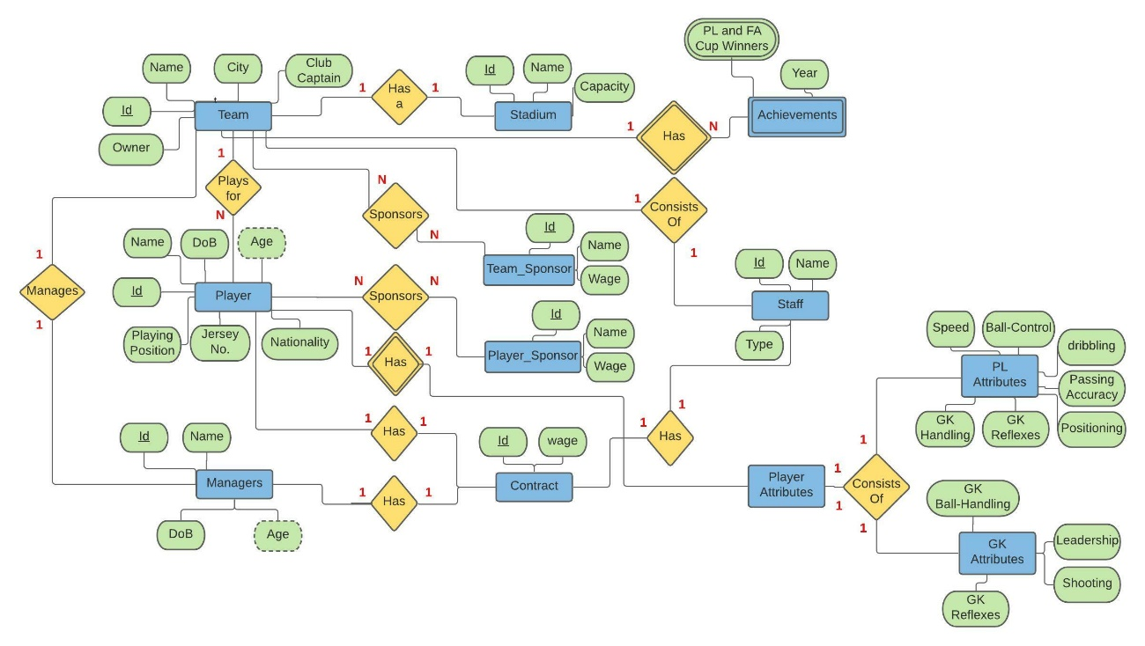

# Normalization:

Establishing relationships between the created tables is the process of normalization, by organising data in the database and eliminating redundancy making the database more flexible and inconsistent dependency. Below each of the tables are explained below, primary, and foreign keys are displayed, explaining which form the tables are in. In the Achievements table the ‘Fa Winners’ and ‘PL winners’ was a multivalued attribute, so they have been separated now in that table there is no multivalued attribute. The same goes for Sponsors. In our ERD Diagram before planning we had a relation: **Sponsor** entity is connected to both the **Player** and **Team** via ‘*Sponsors’* relation. **(Many to Many).** But the sponsors table is broken into two tables: Team Sponsor and Player Sponsor.

### Team:

* ➔ (**Team_ID (PK),** Team_name, City, President, **Captain_ID(FK), Manager_ID(FK), Stadium_ID(FK)**
* All the attributes of **Team** table fully dependent on **Team_ID(PK).**
* There is no redundancy, so this table is in 1NF.
* There are no partial dependencies, so this table is in 2NF.
* There are no transitive dependencies, so this table is in 3NF.

### Player:

* ➔ (**Player_ID (PK),** Player_name, Player_dob, Player_age, Playing_position, Player_JerseyNo, Player_Nationality, **TeamID (FK), AttributeID (FK), Contract_ID(FK).**
* All the attributes of **Player** table fully Functionally dependent on **Player_ID (PK).**
* There is no multivalued attribute, so this table is in 1NF.
* There are no partial dependencies, so this table is in 2NF.
* There are no transitive dependencies, so this table is in 3NF.

### Contract:

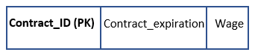

* **ContractID**➔ (Contract_expiration, Wage)
* All the attributes of **Contract** table fully dependent on **Contract_ID (PK).**
* There is no multivalued attribute & no redundancy, so this table is in 1NF.
* There are no partial dependencies, so this table is in 2NF.
* There are no transitive dependencies, so this table is in 3NF.

### Managers:

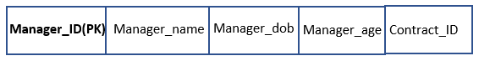

* **ManagerID**➔ (Manager_name, Manager_dob, Manager_age, **Contract_ID(FK).**
* All the attributes of **Manager** table fully dependent on **Manager_ID (PK).**
* There is no multivalued attribute & no redundancy, so this table is in 1NF.
* There are no partial dependencies, so this table is in 2NF.
* There are no transitive dependencies, so this table is in 3NF.

### Staff:

* **StaffID**➔ (Staff_member_name, Staff_type, **Team_ID (FK), Contract_ID (FK).**
* All the attributes of **Staff** table fully dependent on **Staff_ID (PK).**
* There is no multivalued attribute & no redundancy, so this table is in 1NF.
* There are no partial dependencies, so this table is in 2NF.
* There are no transitive dependencies, so this table is in 3NF

### Team_Sponsor:

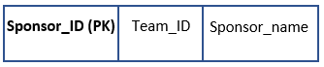

* **SponsorID (PK)** ➔(**Team_ID(FK),** Sponsor_name)
* Few attributes of **Team_Sponsor** table partially dependent on **Sponsor_ID (PK).**
* To reduce the partially dependency and repeating attributes we made another table named Player Sponsor Table.
* There is no multivalued attribute, so this table is in 1NF.
* There are no partial dependencies, so this table is in 2NF.
* There are no transitive dependencies, so this table is in 3NF

### Player_Sponsor:

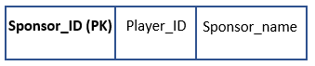

* **SponsorID (PK)** ➔(**Player_ID(FK),** Sponsor_name)
* Few attributes of **Player_Sponsor** table partially dependent on **Sponsor_ID (PK).**
* To reduce the partially dependency and repeating attributes we made another table named Team Sponsor Table.
* There is no multivalued attribute, so this table is in 1NF.
* There are no partial dependencies, so this table is in 2NF.
* There are no transitive dependencies, so this table is in 3NF

### Player_Attribute:

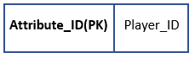

* **Attribute_ID**➔(**Player_ID,) (FK)**
* All the attributes of **Attribute** table fully dependent on **Attribute_ID (PK)**.
* There is no multivalued attribute, so this table is in 1NF.
* There are no partial dependencies, so this table is in 2NF.
* There are no transitive dependencies, so this table is in 3NF.

### GK_Attributes:

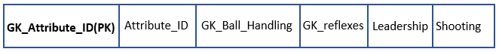

* **GK_Attribute_ID** ➔(Attribute_ID(FK), GK_Ball_Handling, GK_reflexes, Leadership, Shooting)
* All the attributes of **GK_Attribute_ID** table fully dependent on **GK_Attribute_ID(PK)**.
* There is no multivalued attribute, so this table is in 1NF.
* There are no partial dependencies, so this table is in 2NF.
* There are no transitive dependencies, so this table is in 3NF.

### PL_Attributes:

* **PL_Attribute_ID** ➔ (Attribute_ID(FK), Speed, Ball_Control, Dribbling, Passing_Accuracy, Positioning.)
* All the attributes of **PL Attribute** table fully dependent on **PL_Attribute_ID (PK)**.
* There is no multivalued attribute, so this table is in 1NF.
* There are no partial dependencies, so this table is in 2NF.
* There are no transitive dependencies, so this table is in 3NF.

### Stadium:

* **Stadium_ID** ➔ (Stadium_name, Stadium_capacity)
* All the attributes of StadiumTable fully dependent on **Stadium_ID(PK).**
* There is no multivalued attribute, so this table is in 1NF.
* There are no partial dependencies, so this table is in 2NF.
* There are no transitive dependencies, so this table is in 3NF.

### Achievement:

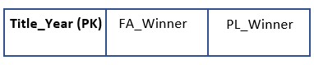

* **Title_Year** ➔ (FA_Winner, PL_Winner)
* All the attributes of **Achievement** Table fully dependent on **Title_Year (PK)**.
* There is no multivalued attribute, so this table is in 1NF.
* There are no partial dependencies, so this table is in 2NF.
* There are no transitive dependencies, so this table is in 3NF.

# Query Optimisation Using indexes:

-- Indexing has been done after creating the tables (Table Creation, Insert into scripts to follow)

-- Indexes are added only to columns that we think will be accessed more often

CREATE INDEX contract_exp_index on CONTRACT(CONTRACT_EXPIRATION);

CREATE INDEX player_composite_index on PLAYER (PLAYER_NAME, PLAYER_AGE, PLAYING_POSITION);

CREATE INDEX team_name_index on TEAM(TEAM_NAME);

CREATE INDEX manager_composite_index on MANAGERS (MANAGER_NAME, MANAGER_AGE);

## Example 1:

To return a result from a specific team in the database whose contracts would be expiring in this coming year: This query will return the players whose contracts is expiring.

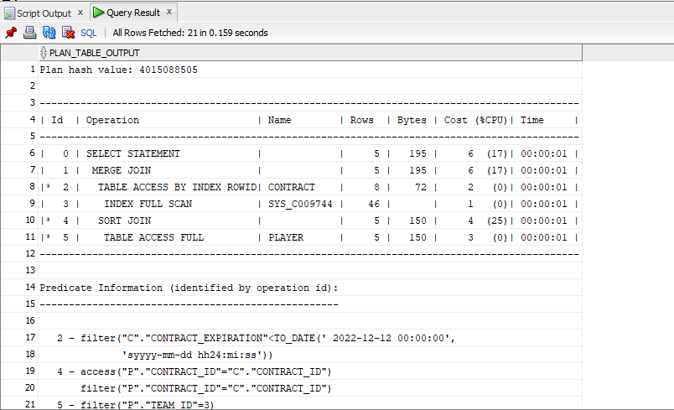Without adding any indexes, we are getting the cost of **(6)**

After adding indexes:

CREATE INDEX contract_exp_index on CONTRACT(CONTRACT_EXPIRATION);

CREATE INDEX player_composite_index on PLAYER (PLAYER_NAME, PLAYER_AGE, PLAYING_POSITION);

The cost is reduced: This can see be seen below.

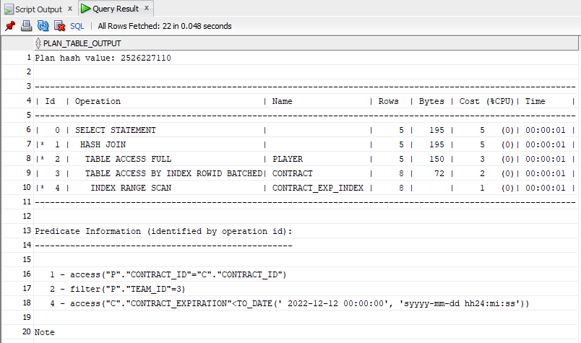

The effect that lowers costs has is that the query is executed more swiftly than before.

## Example 2:

This query will display the strikers who are ageing above 30. Football Scouts, Managers can use this data to plan on purchasing new strikers for future seasons. This Queries below are used to get the report performance.

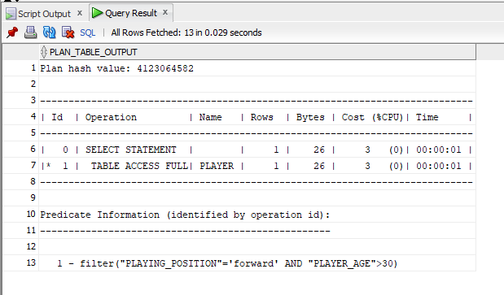- ANALYZE TABLE PLAYER COMPUTE STATISTICS;  
- EXPLAIN PLAN FOR SELECT PLAYER_NAME, PLAYER_AGE, PLAYING_POSITION from PLAYER where - PLAYING_POSITION = 'forward' AND PLAYER_AGE > 30;  
- SELECT * FROM TABLE(DBMS_XPLAN.DISPLAY);

The returned result resulted with the cost of 3. Now the create Index query will be executed to get a lower cost.

CREATE INDEX player_composite_index on PLAYER (PLAYER_NAME, PLAYER_AGE, PLAYING_POSITION);

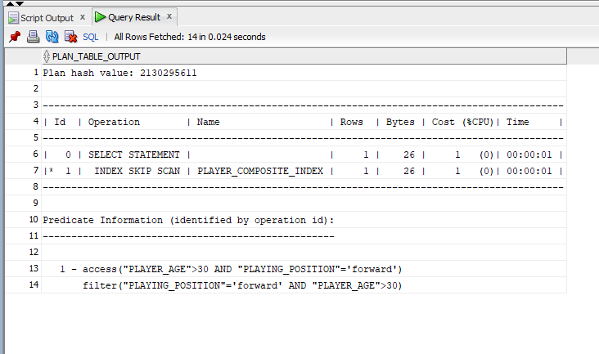

The returned cost result has improved with the create indexes query.

# Database Implementation

### Create Scripts:

-- 1) Create Teams Players

CREATE TABLE TEAM

(

team_id INT PRIMARY KEY,

team_name VARCHAR(100),

city VARCHAR(100),

president VARCHAR(100),

captain_id INT,

manager_id INT,

stadium_id INT

-- Need to add foreign key for manager, captain, and stadium

);

-- 2) Create Players and Attribute Table

CREATE TABLE PLAYER

(

player_id INT PRIMARY KEY,

player_name VARCHAR(100),

player_dob DATE,

player_age INT,

playing_position VARCHAR(100),

player_jerseyNo INT,

player_nationality VARCHAR(100),

team_id INT, -- Foreign key from team

attribute_id INT, -- Foreign key from attribute

contract_id INT -- foreign key from Contract table

);

-- Need to put View for age, drieved attribute

CREATE TABLE PLAYER_ATTRIBUTE

(

attribute_id INT PRIMARY KEY,

player_id INT -- Foreign key from Player table

);

CREATE TABLE GK_ATTRIBUTES

(

gk_attribute_id INT PRIMARY KEY,

attribute_id INT, -- Foreign key from Attributes table

-- Rating below is out of 10 with 10 being the highest

gk_ball_handling INT,

gk_reflexes INT,

leadership INT,

shooting INT

);

CREATE TABLE PL_ATTRIBUTES

(

pl_attribute_id INT PRIMARY KEY,

attribute_id INT, -- Foreign key from Pl attrubutes table

-- Rating below is out of 10 with 10 being the highest

speed INT,

ball_control INT,

dribbling INT,

passing_accuracy INT,

positioning INT

);

-- 3) Create Stadium Table

CREATE TABLE STADIUM

(

stadium_id INT PRIMARY KEY,

stadium_name VARCHAR(100),

stadium_capacity INT

);

-- 4) Create table Achievement

CREATE TABLE ACHIEVEMENT

(

title_year INT PRIMARY KEY,

FA_winner INT,

PL_Winner INT

-- both the FA_winner and PL_winner is the foreign key from Teams table

);

-- 5) Create Sponsors tables

CREATE TABLE PLAYER_SPONSOR

(

sponsor_id INT PRIMARY KEY,

player_id INT, -- Foreign key from Player table.

sponsor_name VARCHAR(100)

);

CREATE TABLE TEAM_SPONSOR

(

sponsor_id INT PRIMARY KEY,

team_id INT, -- Foreign key from Club table.

sponsor_name VARCHAR(100)

);

-- 6) Create Staff Table

CREATE TABLE STAFF

(

staff_id INT PRIMARY KEY,

staff_member_name VARCHAR(100),

staff_type VARCHAR(100), -- e.g medical or coach

team_id INT,

contract_id INT -- foreign key from Contract table

);

-- 7) Create Manager Table

CREATE TABLE MANAGERS

(

manager_id INT PRIMARY KEY,

manager_name VARCHAR(100),

manager_dob date,

manager_age INT,

contract_id INT -- foreign key from Contract table

);

-- Need to put View for age, drieved attribute

-- 8) Create Contract Table

CREATE TABLE CONTRACT

(

contract_id INT PRIMARY KEY,

contract_expiration DATE,

wage INT

);

### Adding Foreign Keys:

-- 1) Adding foreigne keys to TEAM Table

ALTER TABLE TEAM

ADD FOREIGN KEY (captain_id)

REFERENCES PLAYER(player_id)

deferrable initially deferred; -- Add caption foreignkey in Teams table

ALTER TABLE TEAM

ADD FOREIGN KEY (manager_id)

REFERENCES MANAGERS(manager_id)

deferrable initially deferred; -- Add manager foreignkey in Teams table

ALTER TABLE TEAM

ADD FOREIGN KEY (stadium_id)

REFERENCES STADIUM(stadium_id); -- Add stadium foreignkey in Teams table

-- 2) Adding foreign key to Player

ALTER TABLE PLAYER

ADD FOREIGN KEY (team_id)

REFERENCES TEAM(team_id); -- Add team foreignkey in player table

ALTER TABLE PLAYER

ADD FOREIGN KEY (attribute_id)

REFERENCES PLAYER_ATTRIBUTE(attribute_id)

deferrable initially deferred; -- Add attribute foreignkey in player table

ALTER TABLE PLAYER

ADD FOREIGN KEY (contract_id)

REFERENCES CONTRACT(contract_id)

deferrable initially deferred; -- Add contract foreignkey in player table

-- 3) Adding foreign key to PLAYER_ATTRIBUTE

ALTER TABLE PLAYER_ATTRIBUTE

ADD FOREIGN KEY (player_id)

REFERENCES PLAYER(player_id); -- Add player_id foreignkey in PLAYER table

-- 4) Adding foreign key to GK_ATTRIBUTES

ALTER TABLE GK_ATTRIBUTES

ADD FOREIGN KEY (attribute_id)

REFERENCES PLAYER_ATTRIBUTE(attribute_id); -- Add attribute foreignkey in GK_Attribute table

-- 5) Adding foreign key to GK_ATTRIBUTES

ALTER TABLE PL_ATTRIBUTES

ADD FOREIGN KEY (attribute_id)

REFERENCES PLAYER_ATTRIBUTE(attribute_id); -- Add attribute foreignkey in PL_ATTRIBUTES table

-- 6) Adding foreign key to Achievement

ALTER TABLE ACHIEVEMENT

ADD FOREIGN KEY (FA_winner)

REFERENCES TEAM(team_id); -- Add attribute foreignkey in ACHIEVEMENT table

ALTER TABLE ACHIEVEMENT

ADD FOREIGN KEY (PL_Winner)

REFERENCES TEAM(team_id); -- Add attribute foreignkey in ACHIEVEMENT table

-- 7) Adding foreign key to player_sponsor

ALTER TABLE PLAYER_SPONSOR

ADD FOREIGN KEY (player_id)

REFERENCES PLAYER(player_id); -- Add player foreignKey in PLAYER_SPONSOR table

-- 8) Adding foreign key to team_sponsor

ALTER TABLE TEAM_SPONSOR

ADD FOREIGN KEY (team_id)

REFERENCES TEAM(team_id); -- Add team foreignKey in TEAM_SPONSOR table

-- 9) Adding foreign key to Staff

ALTER TABLE STAFF

ADD FOREIGN KEY (team_id)

REFERENCES TEAM(team_id);

-- Add team foreignKey in STAFF table

ALTER TABLE STAFF

ADD FOREIGN KEY (contract_id)

REFERENCES CONTRACT(contract_id); -- Add contract foreignKey in STAFF table

-- 10) Adding foreign key to Manager

ALTER TABLE MANAGERS

ADD FOREIGN KEY (contract_id)

REFERENCES CONTRACT(contract_id); -- Add contract foreignKey in MANAGERS table

# Insert into Scripts:

-- 1) INSERTING Stadium

INSERT INTO

STADIUM

(stadium_id, stadium_name, stadium_capacity)

VALUES

(1, 'Stamford Bridge', 41837); -- Chelsea

INSERT INTO

STADIUM

(stadium_id, stadium_name, stadium_capacity)

VALUES

(2, 'Old Trafford', 74140); -- Man. United

INSERT INTO

STADIUM

(stadium_id, stadium_name, stadium_capacity)

VALUES

(3, 'Etihad Stadium', 55017); -- Man. City

INSERT INTO

STADIUM

(stadium_id, stadium_name, stadium_capacity)

VALUES

(4, 'Anfield', 53394); -- Liverpool

INSERT INTO

STADIUM

(stadium_id, stadium_name, stadium_capacity)

VALUES

(5, 'Emirates Stadium', 60260); -- Arsenal

-- 2) INSERTING Contracts

INSERT INTO CONTRACT

(contract_id, contract_expiration, wage)

VALUES

(1, TO_DATE('01/12/2022', 'DD/MM/YYYY'), 75000); -- Tuchel (chelsea's Manager

INSERT INTO CONTRACT

(contract_id, contract_expiration, wage)

VALUES

(6, TO_DATE('01/12/2024', 'DD/MM/YYYY'), 145000); -- Azpilicueta (chelsea's Captain

INSERT INTO CONTRACT

(contract_id, contract_expiration, wage)

VALUES

(2, TO_DATE('01/12/2023', 'DD/MM/YYYY'), 160000); -- Ole (Man U's Manager)

INSERT INTO CONTRACT

(contract_id, contract_expiration, wage)

VALUES

(7, TO_DATE('01/12/2025', 'DD/MM/YYYY'), 190000); -- Maguire (Man U's Captain)

INSERT INTO CONTRACT

(contract_id, contract_expiration, wage)

VALUES

(3, TO_DATE('01/12/2021', 'DD/MM/YYYY'), 417500); -- Pep (Man C's Manager)

INSERT INTO CONTRACT

(contract_id, contract_expiration, wage)

VALUES

(8, TO_DATE('01/12/2022', 'DD/MM/YYYY'), 150000); -- Fernandinho (Man C's Captain)

INSERT INTO CONTRACT

(contract_id, contract_expiration, wage)

VALUES

(4, TO_DATE('01/12/2024', 'DD/MM/YYYY'), 313500); -- Klopp (Liverpool's Manager)

INSERT INTO CONTRACT

(contract_id, contract_expiration, wage)

VALUES

(9, TO_DATE('01/12/2027', 'DD/MM/YYYY'), 100000); -- Henderson (Liverpool's Captain)

INSERT INTO CONTRACT

(contract_id, contract_expiration, wage)

VALUES

(5, TO_DATE('01/12/2024', 'DD/MM/YYYY'), 105000); -- Arteta (Arsenal's Manager)

INSERT INTO CONTRACT

(contract_id, contract_expiration, wage)

VALUES

(10, TO_DATE('01/12/2024', 'DD/MM/YYYY'), 250000); -- Aubameyang (Arsenal's Captain)

-- 3) INSERTING Teams, Captains and Managers (Cyclic Foreign keys)

--BEGIN

INSERT into TEAM

(team_id, team_name, city, president, captain_id, manager_id, stadium_id)

VALUES

(1, 'Chelsea', 'London', 'Roman Arkadyevich Abramovich', 1, 1, 1)

INSERT into TEAM

(team_id, team_name, city, president, captain_id, manager_id, stadium_id)

VALUES

(2, 'Man United', 'Manchester', 'Ed Woodward', 2, 2, 2);

INSERT into TEAM

(team_id, team_name, city, president, captain_id, manager_id, stadium_id)

VALUES

(3, 'Man City', 'Manchester', 'Ferran Soriano', 3, 3, 3);

INSERT into TEAM

(team_id, team_name, city, president, captain_id, manager_id, stadium_id)

VALUES

(4, 'Liverpool', 'Liverpool', 'Michael S. Gordon', 4, 4, 4);

INSERT into TEAM

(team_id, team_name, city, president, captain_id, manager_id, stadium_id)

VALUES

(5, 'Arsenal', 'London', 'Stan Kroenke', 5, 5, 5);

-- Managers

INSERT into MANAGERS

(manager_id, manager_name, manager_dob, manager_age, contract_id)

VALUES

(1, 'Thomas Tuchel', TO_DATE('29/08/1973', 'DD/MM/YYYY'), 47, 1);

INSERT into MANAGERS

(manager_id, manager_name, manager_dob, manager_age, contract_id)

VALUES

(2, 'Ole Gunnar Solskjær', TO_DATE('26/02/1973', 'DD/MM/YYYY'), 48, 2);

INSERT into MANAGERS

(manager_id, manager_name, manager_dob, manager_age, contract_id)

VALUES

(3, 'Pep Guardiola', TO_DATE('18/01/1971', 'DD/MM/YYYY'), 50, 3);

INSERT into MANAGERS

(manager_id, manager_name, manager_dob, manager_age, contract_id)

VALUES

(4, 'Jürgen Klopp', TO_DATE('16/06/1967', 'DD/MM/YYYY'), 54, 4);

INSERT into MANAGERS

(manager_id, manager_name, manager_dob, manager_age, contract_id)

VALUES

(5, 'Mikel Arteta', TO_DATE('26/03/1982', 'DD/MM/YYYY'), 39, 5);

-- Captains

INSERT INTO PLAYER -- Chelsea's Captain

(player_id, player_name, player_dob, player_age, playing_position, player_jerseyNo, player_nationality, team_id, attribute_id, contract_id)

VALUES

(1, 'César Azpilicueta', TO_DATE('28/08/1989', 'DD/MM/YYYY'), 31, 'centre-back', 28, 'Spanish', 1, 1, 6);

INSERT INTO PLAYER -- MANU's Captain

(player_id, player_name, player_dob, player_age, playing_position, player_jerseyNo, player_nationality, team_id, attribute_id, contract_id)

VALUES

(2, 'Harry Maguire', TO_DATE('05/03/1993', 'DD/MM/YYYY'), 28, 'centre-back', 6, 'English', 2, 2, 7);

INSERT INTO PLAYER -- MANC's Captain

(player_id, player_name, player_dob, player_age, playing_position, player_jerseyNo, player_nationality, team_id, attribute_id, contract_id)

VALUES

(3, 'Fernandinho', TO_DATE('04/04/1985', 'DD/MM/YYYY'), 36, 'midfielder', 25, 'Brazilian', 3, 3, 8);

INSERT INTO PLAYER -- Liverpool's Captain

(player_id, player_name, player_dob, player_age, playing_position, player_jerseyNo, player_nationality, team_id, attribute_id, contract_id)

VALUES

(4, 'Jordan Henderson', TO_DATE('17/06/1990', 'DD/MM/YYYY'), 14, 'midfielder', 31, 'English', 4, 4, 9);

INSERT INTO PLAYER -- Arsenal's Captain

(player_id, player_name, player_dob, player_age, playing_position, player_jerseyNo, player_nationality, team_id, attribute_id, contract_id)

VALUES

(5, 'Pierre-Emerick Aubameyang', TO_DATE('18/06/1989', 'DD/MM/YYYY'), 14, 'striker', 32, 'French', 5, 5, 10);

-- Captains Attributes

INSERT INTO PLAYER_ATTRIBUTE -- Chelsea's Azpilicueta

(attribute_id, player_id)

values

(1,1);

INSERT INTO PL_ATTRIBUTES

(pl_attribute_id, attribute_id, speed, ball_control, dribbling, passing_accuracy, positioning)

VALUES

(1, 1, 7,7,6,7,8);

INSERT INTO PLAYER_ATTRIBUTE -- Manu's Harry

(attribute_id, player_id)

values

(2,2);

INSERT INTO PL_ATTRIBUTES

(pl_attribute_id, attribute_id, speed, ball_control, dribbling, passing_accuracy, positioning)

VALUES

(2, 2, 7,7,6,7,8);

INSERT INTO PLAYER_ATTRIBUTE -- Manc's Fernandinho

(attribute_id, player_id)

values

(3,3);

INSERT INTO PL_ATTRIBUTES

(pl_attribute_id, attribute_id, speed, ball_control, dribbling, passing_accuracy, positioning)

VALUES

(3, 3, 8,7,6,8,7);

INSERT INTO PLAYER_ATTRIBUTE -- Liverpool's Henderson

(attribute_id, player_id)

values

(4,4);

INSERT INTO PL_ATTRIBUTES

(pl_attribute_id, attribute_id, speed, ball_control, dribbling, passing_accuracy, positioning)

VALUES

(4, 4, 6,8,6,8,8);

INSERT INTO PLAYER_ATTRIBUTE -- Arsenal's Aubameyang

(attribute_id, player_id)

values

(5,5);

INSERT INTO PL_ATTRIBUTES

(pl_attribute_id, attribute_id, speed, ball_control, dribbling, passing_accuracy, positioning)

VALUES

(5, 5, 9,7,6,6,7);

-- Insert remaining players into the teams

-- Insert chelsea players

INSERT INTO CONTRACT

(contract_id, contract_expiration, wage)

VALUES

(11, TO_DATE('01/12/2026', 'DD/MM/YYYY'), 120000); -- Kanté (chelsea)

INSERT INTO PLAYER -- Kante (chelsea)

(player_id, player_name, player_dob, player_age, playing_position, player_jerseyNo, player_nationality, team_id, attribute_id, contract_id)

VALUES

(6, 'N-Golo Kanté', TO_DATE('29/03/1991', 'DD/MM/YYYY'), 30, 'central midfielder', 13, 'French', 1, 6, 11);

INSERT INTO PLAYER_ATTRIBUTE -- Kanté (chelsea)

(attribute_id, player_id)

values

(6,6);

INSERT INTO PL_ATTRIBUTES

(pl_attribute_id, attribute_id, speed, ball_control, dribbling, passing_accuracy, positioning)

VALUES

(6, 6, 9,8,7,8,8);

INSERT INTO CONTRACT

(contract_id, contract_expiration, wage)

VALUES

(12, TO_DATE('01/06/2022', 'DD/MM/YYYY'), 120000); -- Silva (chelsea)

INSERT INTO PLAYER -- Silva (chelsea)

(player_id, player_name, player_dob, player_age, playing_position, player_jerseyNo, player_nationality, team_id, attribute_id, contract_id)

VALUES

(7, 'Thiago Silva', TO_DATE('22/09/1984', 'DD/MM/YYYY'), 36, 'centre back', 6, 'Brazilian', 1, 7, 12);

INSERT INTO PLAYER_ATTRIBUTE -- Silva (chelsea)

(attribute_id, player_id)

values

(7,7);

INSERT INTO PL_ATTRIBUTES

(pl_attribute_id, attribute_id, speed, ball_control, dribbling, passing_accuracy, positioning)

VALUES

(7, 7, 6,7,6,7,8);

INSERT INTO CONTRACT

(contract_id, contract_expiration, wage)

VALUES

(13, TO_DATE('01/06/2025', 'DD/MM/YYYY'), 117000); -- Timo Werner (chelsea)

INSERT INTO PLAYER -- Timo Werner (chelsea)

(player_id, player_name, player_dob, player_age, playing_position, player_jerseyNo, player_nationality, team_id, attribute_id, contract_id)

VALUES

(8, 'Timo Werner', TO_DATE('06/03/1996', 'DD/MM/YYYY'), 25, 'forward ', 1, 'German', 1, 8, 13);

INSERT INTO PLAYER_ATTRIBUTE -- Timo Werner (chelsea)

(attribute_id, player_id)

values

(8,8);

INSERT INTO PL_ATTRIBUTES

(pl_attribute_id, attribute_id, speed, ball_control, dribbling, passing_accuracy, positioning)

VALUES

(8, 8, 6,7,6,7,7);

INSERT INTO CONTRACT

(contract_id, contract_expiration, wage)

VALUES

(14, TO_DATE('01/12/2026', 'DD/MM/YYYY'), 120000); -- Kepa (chelsea)

INSERT INTO PLAYER -- Kepa (chelsea)

(player_id, player_name, player_dob, player_age, playing_position, player_jerseyNo, player_nationality, team_id, attribute_id, contract_id)

VALUES

(9, 'Kepa Arrizabalaga', TO_DATE('03/10/1994', 'DD/MM/YYYY'), 26, 'goalkeeper', 1, 'Spanish', 1, 9, 14);

INSERT INTO PLAYER_ATTRIBUTE -- Kepa (chelsea)

(attribute_id, player_id)

values

(9,9);

INSERT INTO GK_ATTRIBUTES

(gk_attribute_id, attribute_id, GK_BALL_HANDLING, GK_REFLEXES, LEADERSHIP, SHOOTING)

VALUES

(1, 9, 7,6,4,8);

-- Insert Manchester United Players

INSERT INTO CONTRACT

(contract_id, contract_expiration, wage)

VALUES

(15, TO_DATE('01/12/2026', 'DD/MM/YYYY'), 220000); -- Pogba (Manu)

INSERT INTO PLAYER -- Pogba (Manu)

(player_id, player_name, player_dob, player_age, playing_position, player_jerseyNo, player_nationality, team_id, attribute_id, contract_id)

VALUES

(10, 'Paul Pogba', TO_DATE('15/03/1993', 'DD/MM/YYYY'), 28, 'central midfielder', 6, 'French', 2, 10, 15);

INSERT INTO PLAYER_ATTRIBUTE -- Pogba (Manu)

(attribute_id, player_id)

values

(10,10);

INSERT INTO PL_ATTRIBUTES

(pl_attribute_id, attribute_id, speed, ball_control, dribbling, passing_accuracy, positioning)

VALUES

(10, 10, 7,8,8,9,7);

INSERT INTO CONTRACT

(contract_id, contract_expiration, wage)

VALUES

(16, TO_DATE('01/12/2026', 'DD/MM/YYYY'), 120000); -- Rashford (Manu)

INSERT INTO PLAYER -- Rashford (Manu)

(player_id, player_name, player_dob, player_age, playing_position, player_jerseyNo, player_nationality, team_id, attribute_id, contract_id)

VALUES

(11, 'Marcus Rashford', TO_DATE('31/10/1997', 'DD/MM/YYYY'), 23, 'forward ', 11, 'English', 2, 11, 16);

INSERT INTO PLAYER_ATTRIBUTE -- Rashford (Manu)

(attribute_id, player_id)

values

(11,11);

INSERT INTO PL_ATTRIBUTES

(pl_attribute_id, attribute_id, speed, ball_control, dribbling, passing_accuracy, positioning)

VALUES

(11, 11, 9,7,6,6,5);

INSERT INTO CONTRACT

(contract_id, contract_expiration, wage)

VALUES

(17, TO_DATE('01/12/2024', 'DD/MM/YYYY'), 120000); -- Martial (Manu)

INSERT INTO PLAYER -- Martial (Manu)

(player_id, player_name, player_dob, player_age, playing_position, player_jerseyNo, player_nationality, team_id, attribute_id, contract_id)

VALUES

(12, 'Anthony Martial', TO_DATE('5/12/1995', 'DD/MM/YYYY'), 25, 'forward ', 9, 'French', 2, 12, 17);

INSERT INTO PLAYER_ATTRIBUTE -- Martial (Manu)

(attribute_id, player_id)

values

(12,12);

INSERT INTO PL_ATTRIBUTES

(pl_attribute_id, attribute_id, speed, ball_control, dribbling, passing_accuracy, positioning)

VALUES

(12, 12, 8,7,7,6,6);

INSERT INTO CONTRACT

(contract_id, contract_expiration, wage)

VALUES

(18, TO_DATE('01/12/2023', 'DD/MM/YYYY'), 130000); -- Cavani (Manu)

INSERT INTO PLAYER -- Cavani (Manu)

(player_id, player_name, player_dob, player_age, playing_position, player_jerseyNo, player_nationality, team_id, attribute_id, contract_id)

VALUES

(13, 'Edinson Cavani', TO_DATE('14/02/1987', 'DD/MM/YYYY'), 34, 'forward', 7, 'Uruguayan', 2, 13, 18);

INSERT INTO PLAYER_ATTRIBUTE -- Cavani (Manu)

(attribute_id, player_id)

values

(13,13);

INSERT INTO PL_ATTRIBUTES

(pl_attribute_id, attribute_id, speed, ball_control, dribbling, passing_accuracy, positioning)

VALUES

(13, 13, 6,7,6,6,5);

INSERT INTO CONTRACT

(contract_id, contract_expiration, wage)

VALUES

(19, TO_DATE('01/12/2026', 'DD/MM/YYYY'), 120000); -- de Gea (Manu)

INSERT INTO PLAYER -- de Gea (Manu)

(player_id, player_name, player_dob, player_age, playing_position, player_jerseyNo, player_nationality, team_id, attribute_id, contract_id)

VALUES

(14, 'David de Gea', TO_DATE('07/11/1990', 'DD/MM/YYYY'), 30, 'goalkeeper', 1, 'Spanish', 2, 14, 19);

INSERT INTO PLAYER_ATTRIBUTE -- de Gea (Manu)

(attribute_id, player_id)

values

(14,14);

INSERT INTO GK_ATTRIBUTES

(gk_attribute_id, attribute_id, GK_BALL_HANDLING, GK_REFLEXES, LEADERSHIP, SHOOTING)

VALUES

(2, 14, 7,6,4,8);

-- Insert players for Manchester City

INSERT INTO CONTRACT

(contract_id, contract_expiration, wage)

VALUES

(20, TO_DATE('01/12/2025', 'DD/MM/YYYY'), 170000); -- Sterling (Manc)

INSERT INTO PLAYER -- Sterling (Manc)

(player_id, player_name, player_dob, player_age, playing_position, player_jerseyNo, player_nationality, team_id, attribute_id, contract_id)

VALUES

(15, 'Raheem Sterling', TO_DATE('08/12/1994', 'DD/MM/YYYY'), 26, 'winger', 10, 'English', 3, 15, 20);

INSERT INTO PLAYER_ATTRIBUTE -- Sterling (Manc)

(attribute_id, player_id)

values

(15,15);

INSERT INTO PL_ATTRIBUTES

(pl_attribute_id, attribute_id, speed, ball_control, dribbling, passing_accuracy, positioning)

VALUES

(15, 15, 7,8,8,8,7);

INSERT INTO CONTRACT

(contract_id, contract_expiration, wage)

VALUES

(21, TO_DATE('01/12/2026', 'DD/MM/YYYY'), 190000); -- De Bruyne (Manc)

INSERT INTO PLAYER -- De Bruyne (Manc)

(player_id, player_name, player_dob, player_age, playing_position, player_jerseyNo, player_nationality, team_id, attribute_id, contract_id)

VALUES

(16, 'Kevin De Bruyne', TO_DATE('28/06/1991', 'DD/MM/YYYY'), 30, 'midfielder', 17, 'Belgium', 3, 16, 21);

INSERT INTO PLAYER_ATTRIBUTE -- De Bruyne (Manc)

(attribute_id, player_id)

values

(16,16);

INSERT INTO PL_ATTRIBUTES

(pl_attribute_id, attribute_id, speed, ball_control, dribbling, passing_accuracy, positioning)

VALUES

(16, 16, 7,8,8,9,8);

INSERT INTO CONTRACT

(contract_id, contract_expiration, wage)

VALUES

(22, TO_DATE('01/12/2026', 'DD/MM/YYYY'), 190000); -- Mahrez (Manc)

INSERT INTO PLAYER -- Mahrez (Manc)

(player_id, player_name, player_dob, player_age, playing_position, player_jerseyNo, player_nationality, team_id, attribute_id, contract_id)

VALUES

(17, 'Riyad Mahrez', TO_DATE('21/02/1991', 'DD/MM/YYYY'), 26, 'midfielder', 17, 'Algerian', 3, 17, 22);

INSERT INTO PLAYER_ATTRIBUTE -- Mahrez (Manc)

(attribute_id, player_id)

values

(17,17);

INSERT INTO PL_ATTRIBUTES

(pl_attribute_id, attribute_id, speed, ball_control, dribbling, passing_accuracy, positioning)

VALUES

(17, 17, 7,8,8,9,8);

INSERT INTO CONTRACT

(contract_id, contract_expiration, wage)

VALUES

(23, TO_DATE('01/12/2026', 'DD/MM/YYYY'), 120000); -- Ederson (Manc)

INSERT INTO PLAYER -- Ederson (Manc)

(player_id, player_name, player_dob, player_age, playing_position, player_jerseyNo, player_nationality, team_id, attribute_id, contract_id)

VALUES

(18, 'Ederson Santana de Moraes', TO_DATE('17/08/1993', 'DD/MM/YYYY'), 27, 'goalkeeper', 1, 'Brazilian', 3, 18, 23);

INSERT INTO PLAYER_ATTRIBUTE -- Ederson (Manc)

(attribute_id, player_id)

values

(18,18);

INSERT INTO GK_ATTRIBUTES

(gk_attribute_id, attribute_id, GK_BALL_HANDLING, GK_REFLEXES, LEADERSHIP, SHOOTING)

VALUES

(3, 14, 7,6,4,8);

-- Insert players for Liverpool

INSERT INTO CONTRACT

(contract_id, contract_expiration, wage)

VALUES

(24, TO_DATE('01/12/2026', 'DD/MM/YYYY'), 200000); -- Salah (Liverpool)

INSERT INTO PLAYER -- Salah (Liverpool)

(player_id, player_name, player_dob, player_age, playing_position, player_jerseyNo, player_nationality, team_id, attribute_id, contract_id)

VALUES

(19, 'Mohamed Salah', TO_DATE('15/06/1992', 'DD/MM/YYYY'), 29, 'forward ', 11, 'Egyptian', 4, 19, 24);

INSERT INTO PLAYER_ATTRIBUTE -- Salah (Liverpool)

(attribute_id, player_id)

values

(19,19);

INSERT INTO PL_ATTRIBUTES

(pl_attribute_id, attribute_id, speed, ball_control, dribbling, passing_accuracy, positioning)

VALUES

(19, 19, 8,9,8,8,7);

INSERT INTO CONTRACT

(contract_id, contract_expiration, wage)

VALUES

(25, TO_DATE('01/12/2026', 'DD/MM/YYYY'), 170000); -- van Dijk (Liverpool)

INSERT INTO PLAYER -- van Dijk (Liverpool)

(player_id, player_name, player_dob, player_age, playing_position, player_jerseyNo, player_nationality, team_id, attribute_id, contract_id)

VALUES

(20, 'Virgil van Dijk', TO_DATE('08/07/1991', 'DD/MM/YYYY'), 30, 'centre-back', 4, 'Netherlands', 4, 20, 25);

INSERT INTO PLAYER_ATTRIBUTE -- van Dijk (Liverpool)

(attribute_id, player_id)

values

(20,20);

INSERT INTO PL_ATTRIBUTES

(pl_attribute_id, attribute_id, speed, ball_control, dribbling, passing_accuracy, positioning)

VALUES

(20, 20, 9,8,6,8,9);

INSERT INTO CONTRACT

(contract_id, contract_expiration, wage)

VALUES

(26, TO_DATE('01/12/2026', 'DD/MM/YYYY'), 170000); -- Mané (Liverpool)

INSERT INTO PLAYER -- Mané (Liverpool)

(player_id, player_name, player_dob, player_age, playing_position, player_jerseyNo, player_nationality, team_id, attribute_id, contract_id)

VALUES

(21, 'Sadio Mané', TO_DATE('10/04/1992', 'DD/MM/YYYY'), 29, 'winger', 10, 'Senegal', 4, 21, 26);

INSERT INTO PLAYER_ATTRIBUTE -- Mané (Liverpool)

(attribute_id, player_id)

values

(21,21);

INSERT INTO PL_ATTRIBUTES

(pl_attribute_id, attribute_id, speed, ball_control, dribbling, passing_accuracy, positioning)

VALUES

(21, 21, 9,8,7,7,7);

INSERT INTO CONTRACT

(contract_id, contract_expiration, wage)

VALUES

(27, TO_DATE('01/12/2026', 'DD/MM/YYYY'), 120000); -- Alisson (Liverpool)

INSERT INTO PLAYER -- Alisson (Liverpool)

(player_id, player_name, player_dob, player_age, playing_position, player_jerseyNo, player_nationality, team_id, attribute_id, contract_id)

VALUES

(22, 'Alisson Becker', TO_DATE('02/10/1992', 'DD/MM/YYYY'), 28, 'goalkeeper', 1, 'Brazilian', 4, 22, 27);

INSERT INTO PLAYER_ATTRIBUTE -- Alisson (Liverpool)

(attribute_id, player_id)

values

(22,22);

INSERT INTO GK_ATTRIBUTES

(gk_attribute_id, attribute_id, GK_BALL_HANDLING, GK_REFLEXES, LEADERSHIP, SHOOTING)

VALUES

(4, 22, 7,6,4,8);

-- Insert players for Arsenal

INSERT INTO CONTRACT

(contract_id, contract_expiration, wage)

VALUES

(28, TO_DATE('01/12/2026', 'DD/MM/YYYY'), 130000); -- White (Arsenal)

INSERT INTO PLAYER -- White (Arsenal)

(player_id, player_name, player_dob, player_age, playing_position, player_jerseyNo, player_nationality, team_id, attribute_id, contract_id)

VALUES

(23, 'Ben White', TO_DATE('08/10/1997', 'DD/MM/YYYY'), 23, 'centre-back', 4, 'English', 5, 23, 28);

INSERT INTO PLAYER_ATTRIBUTE -- White (Arsenal)

(attribute_id, player_id)

values

(23,23);

INSERT INTO PL_ATTRIBUTES

(pl_attribute_id, attribute_id, speed, ball_control, dribbling, passing_accuracy, positioning)

VALUES

(23, 23, 8,7,6,6,6);

INSERT INTO CONTRACT

(contract_id, contract_expiration, wage)

VALUES

(29, TO_DATE('01/12/2026', 'DD/MM/YYYY'), 110000); -- Saka (Arsenal)

INSERT INTO PLAYER -- Saka (Arsenal)

(player_id, player_name, player_dob, player_age, playing_position, player_jerseyNo, player_nationality, team_id, attribute_id, contract_id)

VALUES

(24, 'Bukayo Saka', TO_DATE('05/09/2001', 'DD/MM/YYYY'), 19, 'winger', 7, 'English', 5, 24, 29);

INSERT INTO PLAYER_ATTRIBUTE -- Saka (Arsenal)

(attribute_id, player_id)

values

(24,24);

INSERT INTO PL_ATTRIBUTES

(pl_attribute_id, attribute_id, speed, ball_control, dribbling, passing_accuracy, positioning)

VALUES

(24, 24, 8,7,6,6,6);

INSERT INTO CONTRACT

(contract_id, contract_expiration, wage)

VALUES

(30, TO_DATE('01/12/2026', 'DD/MM/YYYY'), 110000); -- Xhaka (Arsenal)

INSERT INTO PLAYER -- Xhaka (Arsenal)

(player_id, player_name, player_dob, player_age, playing_position, player_jerseyNo, player_nationality, team_id, attribute_id, contract_id)

VALUES

(25, 'Granit Xhaka', TO_DATE('27/09/1992', 'DD/MM/YYYY'), 28, 'midfielder', 34, 'Switzerland', 5, 25, 30)

INSERT INTO PLAYER_ATTRIBUTE -- Xhaka (Arsenal)

(attribute_id, player_id)

values

(25,25);

INSERT INTO PL_ATTRIBUTES

(pl_attribute_id, attribute_id, speed, ball_control, dribbling, passing_accuracy, positioning)

VALUES

(25, 25, 8,7,6,6,6);

INSERT INTO CONTRACT

(contract_id, contract_expiration, wage)

VALUES

(31, TO_DATE('01/12/2026', 'DD/MM/YYYY'), 120000); -- Bernd Leno (Arsenal)

INSERT INTO PLAYER -- Bernd Leno (Arsenal)

(player_id, player_name, player_dob, player_age, playing_position, player_jerseyNo, player_nationality, team_id, attribute_id, contract_id)

VALUES

(26, 'Bernd Leno', TO_DATE('04/03/1992', 'DD/MM/YYYY'), 29, 'goalkeeper', 1, 'German', 5, 26, 31);

INSERT INTO PLAYER_ATTRIBUTE -- Bernd Leno (Arsenal)

(attribute_id, player_id)

values

(26,26);

INSERT INTO GK_ATTRIBUTES

(gk_attribute_id, attribute_id, GK_BALL_HANDLING, GK_REFLEXES, LEADERSHIP, SHOOTING)

VALUES

(5, 26, 7,6,4,8);

COMMIT;

--END;

-- Inserting Staff and their contract

INSERT INTO CONTRACT

(contract_id, contract_expiration, wage)

VALUES

(32, TO_DATE('01/12/2022', 'DD/MM/YYYY'), 27000); -- Staff Chelsea

INSERT INTO CONTRACT

(contract_id, contract_expiration, wage)

VALUES

(33, TO_DATE('01/12/2021', 'DD/MM/YYYY'), 22000); -- Staff Chelsea

INSERT INTO CONTRACT

(contract_id, contract_expiration, wage)

VALUES

(34, TO_DATE('01/12/2021', 'DD/MM/YYYY'), 22000); -- Staff Chelsea

INSERT INTO CONTRACT

(contract_id, contract_expiration, wage)

VALUES

(35, TO_DATE('01/12/2023', 'DD/MM/YYYY'), 50000); -- Staff Chelsea

INSERT INTO STAFF

(staff_id, staff_member_name, staff_type, team_id, contract_id)

VALUES

(1, 'Eva Carneiro', 'Medical', 1, 32); -- Staff Chelsea

INSERT INTO STAFF

(staff_id, staff_member_name, staff_type, team_id, contract_id)

VALUES

(2, 'Dimitris Kalogiannidis', 'Medical', 1, 33); -- Staff Chelsea

INSERT INTO STAFF

(staff_id, staff_member_name, staff_type, team_id, contract_id)

VALUES

(3, 'Jason Palmer', 'Medical', 1, 34); -- Staff Chelsea

INSERT INTO STAFF

(staff_id, staff_member_name, staff_type, team_id, contract_id)

VALUES

(4, 'Jody Morris', 'Coach', 1, 35); -- Staff Chelsea

INSERT INTO CONTRACT

(contract_id, contract_expiration, wage)

VALUES

(36, TO_DATE('01/06/2023', 'DD/MM/YYYY'), 43000); -- Staff Manu

INSERT INTO CONTRACT

(contract_id, contract_expiration, wage)

VALUES

(37, TO_DATE('01/01/2023', 'DD/MM/YYYY'), 27000); -- Staff Manu

INSERT INTO CONTRACT

(contract_id, contract_expiration, wage)

VALUES

(38, TO_DATE('01/01/2023', 'DD/MM/YYYY'), 32000); -- Staff Manu

INSERT INTO STAFF

(staff_id, staff_member_name, staff_type, team_id, contract_id)

VALUES

(5, 'Rod Thornley', 'Medical', 2, 36); -- Staff Manu

INSERT INTO STAFF

(staff_id, staff_member_name, staff_type, team_id, contract_id)

VALUES

(6, 'Jos van Dijk', 'Medical', 2, 37); -- Staff Manu

INSERT INTO STAFF

(staff_id, staff_member_name, staff_type, team_id, contract_id)

VALUES

(7, 'Eric Ramsay', 'Coach', 2, 38); -- Staff Manu

INSERT INTO CONTRACT

(contract_id, contract_expiration, wage)

VALUES

(39, TO_DATE('01/06/2023', 'DD/MM/YYYY'), 23000); -- Staff Mcity

INSERT INTO CONTRACT

(contract_id, contract_expiration, wage)

VALUES

(40, TO_DATE('01/01/2023', 'DD/MM/YYYY'), 26000); -- Staff Mcity

INSERT INTO STAFF

(staff_id, staff_member_name, staff_type, team_id, contract_id)

VALUES

(8, 'Eduardi Mauri', 'Medical', 3, 39); -- Staff Mcity

INSERT INTO STAFF

(staff_id, staff_member_name, staff_type, team_id, contract_id)

VALUES

(9, 'Steve Sparks', 'Medical', 3, 40); -- Staff Mcity

INSERT INTO CONTRACT

(contract_id, contract_expiration, wage)

VALUES

(41, TO_DATE('01/04/2022', 'DD/MM/YYYY'), 31000); -- Staff Liverpool

INSERT INTO CONTRACT

(contract_id, contract_expiration, wage)

VALUES

(42, TO_DATE('01/12/2021', 'DD/MM/YYYY'), 55000); -- Staff Liverpool

INSERT INTO CONTRACT

(contract_id, contract_expiration, wage)

VALUES

(43, TO_DATE('01/09/2023', 'DD/MM/YYYY'), 37000); -- Staff Liverpool

INSERT INTO STAFF

(staff_id, staff_member_name, staff_type, team_id, contract_id)

VALUES

(10, 'Andrew Massey', 'Medical', 4, 41); -- Staff Liverpool

INSERT INTO STAFF

(staff_id, staff_member_name, staff_type, team_id, contract_id)

VALUES

(11, 'Dr Jim Moxon', 'Medical', 4, 42); -- Staff Liverpool

INSERT INTO STAFF

(staff_id, staff_member_name, staff_type, team_id, contract_id)

VALUES

(12, 'Pepijn Lijnders', 'Coach', 4, 43); -- Staff Liverpool

INSERT INTO CONTRACT

(contract_id, contract_expiration, wage)

VALUES

(44, TO_DATE('01/01/2024', 'DD/MM/YYYY'), 31000); -- Staff Arsenal

INSERT INTO CONTRACT

(contract_id, contract_expiration, wage)

VALUES

(45, TO_DATE('01/11/2025', 'DD/MM/YYYY'), 55000); -- Staff Arsenal

INSERT INTO CONTRACT

(contract_id, contract_expiration, wage)

VALUES

(46, TO_DATE('01/12/2026', 'DD/MM/YYYY'), 37000); -- Staff Arsenal

INSERT INTO STAFF

(staff_id, staff_member_name, staff_type, team_id, contract_id)

VALUES

(13, 'Jordan Reece', 'Medical', 5, 44); -- Staff Arsenal

INSERT INTO STAFF

(staff_id, staff_member_name, staff_type, team_id, contract_id)

VALUES

(14, 'Richard Allison', 'Medical', 5, 45); -- Staff Arsenal

INSERT INTO STAFF

(staff_id, staff_member_name, staff_type, team_id, contract_id)

VALUES

(15, 'Albert Stuivenberg', 'Coach', 5, 46); -- Staff Arsenal

-- Inserting into Achievement

INSERT INTO ACHIEVEMENT

(title_year, pl_winner, fa_winner)

VALUES

(2015, 1, 5):

INSERT INTO ACHIEVEMENT

(title_year, pl_winner, fa_winner)

VALUES

(2014, 3, 5);

INSERT INTO ACHIEVEMENT

(title_year, pl_winner, fa_winner)

VALUES

(2012, 3, 1);

INSERT INTO ACHIEVEMENT

(title_year, pl_winner, fa_winner)

VALUES

(2011, 2, 3);

INSERT INTO ACHIEVEMENT

(title_year, pl_winner, fa_winner)

VALUES

(2010, 1, 1);

INSERT INTO ACHIEVEMENT

(title_year, pl_winner, fa_winner)

VALUES

(2009, 2, 1);

INSERT INTO ACHIEVEMENT

(title_year, pl_winner, fa_winner)

VALUES

(2007, 2, 1);

INSERT INTO ACHIEVEMENT

(title_year, pl_winner, fa_winner)

VALUES

(2006, 1, 4);

-- Insert into Team_Sponsor Table

-- Chelsea sponsor

INSERT INTO TEAM_SPONSOR

(SPONSOR_ID, TEAM_ID, SPONSOR_NAME)

VALUES

(1,1,'Three');

INSERT INTO TEAM_SPONSOR

(SPONSOR_ID, TEAM_ID, SPONSOR_NAME)

VALUES

(2,1,'nike');

-- Man. United sponsors

INSERT INTO TEAM_SPONSOR

(SPONSOR_ID, TEAM_ID, SPONSOR_NAME)

VALUES

(3,2,'adidas');

INSERT INTO TEAM_SPONSOR

(SPONSOR_ID, TEAM_ID, SPONSOR_NAME)

VALUES

(4,2,'Chevrolet');

INSERT INTO TEAM_SPONSOR

(SPONSOR_ID, TEAM_ID, SPONSOR_NAME)

VALUES

(5,2,'DHL');

-- Man. City sponsors

INSERT INTO TEAM_SPONSOR

(SPONSOR_ID, TEAM_ID, SPONSOR_NAME)

VALUES

(6,3,'Etihad Airways');

INSERT INTO TEAM_SPONSOR

(SPONSOR_ID, TEAM_ID, SPONSOR_NAME)

VALUES

(7,3,'PUMA');

INSERT INTO TEAM_SPONSOR

(SPONSOR_ID, TEAM_ID, SPONSOR_NAME)

VALUES

(8,3,'Nissan');

-- Liverpool sponsor

INSERT INTO TEAM_SPONSOR

(SPONSOR_ID, TEAM_ID, SPONSOR_NAME)

VALUES

(9,4,'Standard Chartered');

INSERT INTO TEAM_SPONSOR

(SPONSOR_ID, TEAM_ID, SPONSOR_NAME)

VALUES

(10,4,'nike');

-- Arsenal sponsor

INSERT INTO TEAM_SPONSOR

(SPONSOR_ID, TEAM_ID, SPONSOR_NAME)

VALUES

(11,5,'Emirates');

INSERT INTO TEAM_SPONSOR

(SPONSOR_ID, TEAM_ID, SPONSOR_NAME)

VALUES

(12,5,'adidas');

-- Insert into Player_Sponsor Table

INSERT INTO PLAYER_SPONSOR

(SPONSOR_ID, PLAYER_ID, SPONSOR_NAME)

VALUES

(1, 2, 'nike'); -- Maguire (Manu)

INSERT INTO PLAYER_SPONSOR

(SPONSOR_ID, PLAYER_ID, SPONSOR_NAME)

VALUES

(2, 2, 'puma'); -- Maguire (Manu)

INSERT INTO PLAYER_SPONSOR

(SPONSOR_ID, PLAYER_ID, SPONSOR_NAME)

VALUES

(3, 3, 'puma'); -- Fernandinho (Manc)

INSERT INTO PLAYER_SPONSOR

(SPONSOR_ID, PLAYER_ID, SPONSOR_NAME)

VALUES

(4, 4, 'MaxiNutrition'); -- Jordan Henderson (Liverpool)

INSERT INTO PLAYER_SPONSOR

(SPONSOR_ID, PLAYER_ID, SPONSOR_NAME)

VALUES

(5, 5, 'nike'); -- Pierre-Emerick Aubameyang (Arsenal)

INSERT INTO PLAYER_SPONSOR

(SPONSOR_ID, PLAYER_ID, SPONSOR_NAME)

VALUES

(6, 6, 'adidas'); -- N-Golo Kanté (Chelsea)

INSERT INTO PLAYER_SPONSOR

(SPONSOR_ID, PLAYER_ID, SPONSOR_NAME)

VALUES

(7, 10, 'adidas'); -- Pogba (Manu)

INSERT INTO PLAYER_SPONSOR

(SPONSOR_ID, PLAYER_ID, SPONSOR_NAME)

VALUES

(8, 10, 'PepsiCo'); -- Pogba (Manu)

INSERT INTO PLAYER_SPONSOR

(SPONSOR_ID, PLAYER_ID, SPONSOR_NAME)

VALUES

(9, 10, 'TCL'); -- Pogba (Manu)

INSERT INTO PLAYER_SPONSOR

(SPONSOR_ID, PLAYER_ID, SPONSOR_NAME)

VALUES

(10, 11, 'nike'); -- Rashford (Manu)

INSERT INTO PLAYER_SPONSOR

(SPONSOR_ID, PLAYER_ID, SPONSOR_NAME)

VALUES

(11, 14, 'adidas'); -- De Gea (Manu)

INSERT INTO PLAYER_SPONSOR

(SPONSOR_ID, PLAYER_ID, SPONSOR_NAME)

VALUES

(12, 15, 'New Balance'); -- Sterling (Manc

INSERT INTO PLAYER_SPONSOR

(SPONSOR_ID, PLAYER_ID, SPONSOR_NAME)

VALUES

(13, 16, 'EA SPORTS'); -- Bruyne (Manc)

INSERT INTO PLAYER_SPONSOR

(SPONSOR_ID, PLAYER_ID, SPONSOR_NAME)

VALUES

(14, 17, 'nike'); -- Riyad Mahrez (Manc)

INSERT INTO PLAYER_SPONSOR

(SPONSOR_ID, PLAYER_ID, SPONSOR_NAME)

VALUES

(15, 19, 'adidas'); -- Salah (Liverpool)

INSERT INTO PLAYER_SPONSOR

(SPONSOR_ID, PLAYER_ID, SPONSOR_NAME)

VALUES

(16, 20, 'EA Sports'); -- Virgil van Dijk (Liverpool)

INSERT INTO PLAYER_SPONSOR

(SPONSOR_ID, PLAYER_ID, SPONSOR_NAME)

VALUES

(17, 20, 'nike'); -- Virgil van Dijk (Liverpool)

INSERT INTO PLAYER_SPONSOR

(SPONSOR_ID, PLAYER_ID, SPONSOR_NAME)

VALUES

(18, 21, 'New Balance'); -- Mane (Liverpool)

INSERT INTO PLAYER_SPONSOR

(SPONSOR_ID, PLAYER_ID, SPONSOR_NAME)

VALUES

(19, 22, 'nike'); -- Alisson (Liverpool)

INSERT INTO PLAYER_SPONSOR

(SPONSOR_ID, PLAYER_ID, SPONSOR_NAME)

VALUES

(20, 25, 'Under Armour'); -- Xhaka (Arsenal)

## Created Tables

The screenshot on the left shows all the tables that are created in the database.

# SQL Queries:

### Query 1: Select players from specific team (Manchester City) whose contracts would be expiring this year. (This query would be useful for player contract renewals)

SELECT P.PLAYER_NAME, P.PLAYER_AGE, P.PLAYING_POSITION, C.CONTRACT_EXPIRATION from PLAYER P JOIN CONTRACT C ON (P.CONTRACT_ID = C.CONTRACT_ID) WHERE P.TEAM_ID = 3 AND C.CONTRACT_EXPIRATION **(Muzahir)**

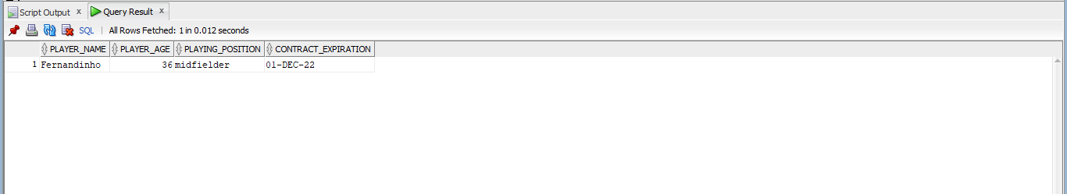

### Query 2: Select players who are strikers, and their age is above 30. (This query would be useful to check if a club needs to buy a new player)

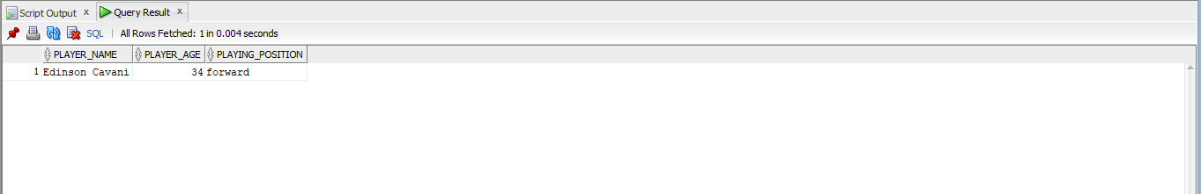SELECT PLAYER_NAME, PLAYER_AGE, PLAYING_POSITION from PLAYER where PLAYING_POSITION = 'forward' AND PLAYER_AGE > 30; **(Muzahir)**

### Query 3: Get Player_name, age and passing_accuracy that plays in midfield for specific team. (This query would be useful to get insights on players attributes)

SELECT P.PLAYER_NAME, P.PLAYER_AGE, A.PASSING_ACCURACY FROM PLAYER P, PL_ATTRIBUTES A WHERE P.TEAM_ID = 3 AND P.PLAYING_POSITION = 'midfielder' AND P.ATTRIBUTE_ID = A.ATTRIBUTE_ID;  **(Muzahir)**

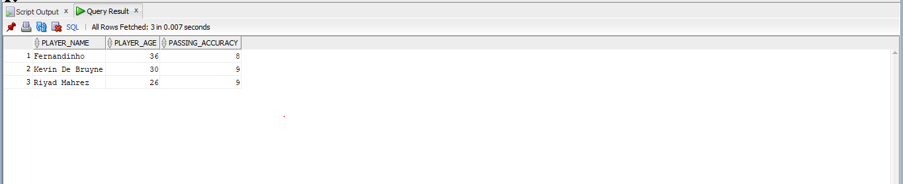

### Query 4: Get team_name with the most PL wins (in this available record)

SELECT T.TEAM_NAME, R.most_pl_wins FROM TEAM T, (SELECT PL_WINNER, COUNT(*) as Most_pl_wins FROM achievement GROUP BY PL_WINNER FETCH FIRST 1 ROWS ONLY) R where R.PL_WINNER = T.TEAM_ID; **(Auwais)**

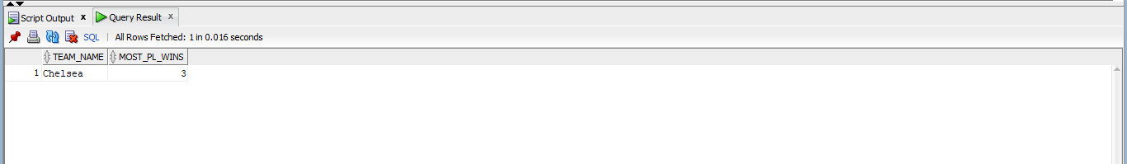

### Query 5: Get Manager contract that will expire within next year. (This query would be useful for manager contract renewals)

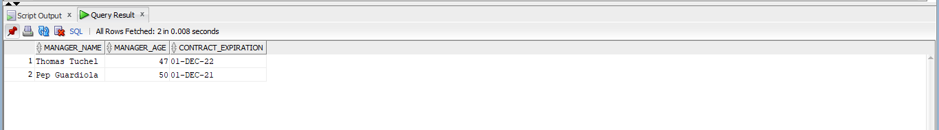SELECT M.MANAGER_NAME, M.MANAGER_AGE, C.CONTRACT_EXPIRATION FROM MANAGERS M INNER JOIN CONTRACT C on (M.CONTRACT_ID = C.CONTRACT_ID) and C.CONTRACT_EXPIRATION < TO_DATE('12/12/2022', 'DD/MM/YYYY'); **(Auwais)**

### Query 6: Get the total of medical and coaches staff in specific team (Chelsea) (This query would be useful to reinforce the staff team that has less members

SELECT STAFF_TYPE, COUNT(*) as Total_members from STAFF where TEAM_ID = 1 GROUP BY STAFF_TYPE;  **(Muzahir)**

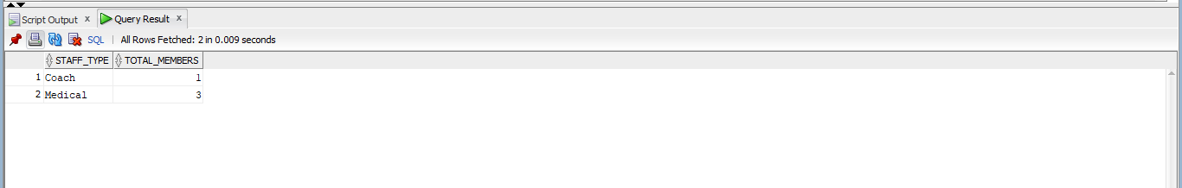

### Query 7: Get PL and FA cup winners from a specific year (2014)

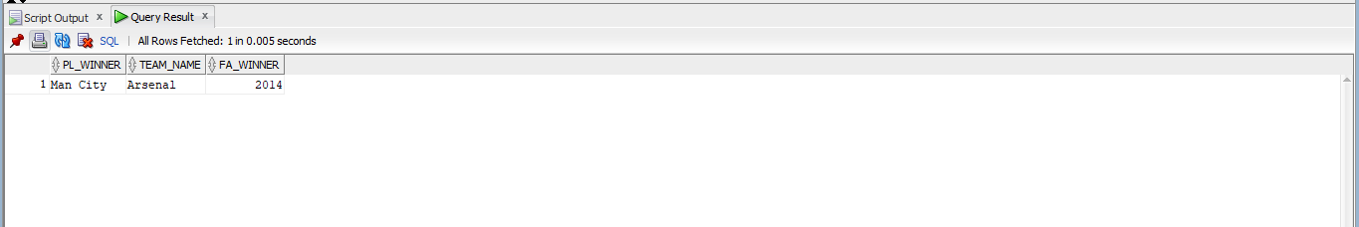SELECT T1.TEAM_NAME as PL_WINNER, T2.TEAM_NAME, R.TITLE_YEAR as FA_WINNER FROM TEAM T1, TEAM T2, (SELECT TITLE_YEAR, FA_WINNER, PL_WINNER FROM ACHIEVEMENT WHERE TITLE_YEAR = 2014) R where R.pl_winner = T1.Team_ID AND R.fa_winner = T2.team_id; **(Auwais)**

### Query 8: Get all sponsors for single specific team (Manchester United)

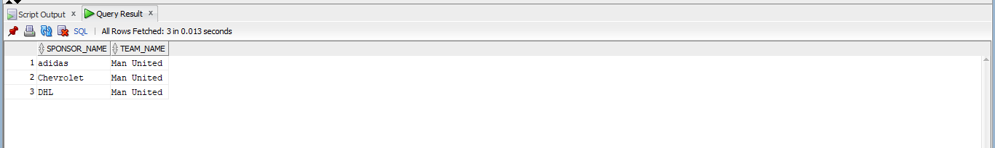SELECT S.SPONSOR_NAME, T.TEAM_NAME FROM TEAM T, TEAM_SPONSOR S WHERE S.TEAM_ID = T.TEAM_ID AND T.TEAM_ID = 2; **(Muzahir)**

### Query 9: Get players from specific team (Liverpool) with wages > 150000/week (This query would be useful to get to know teams wages distribution)

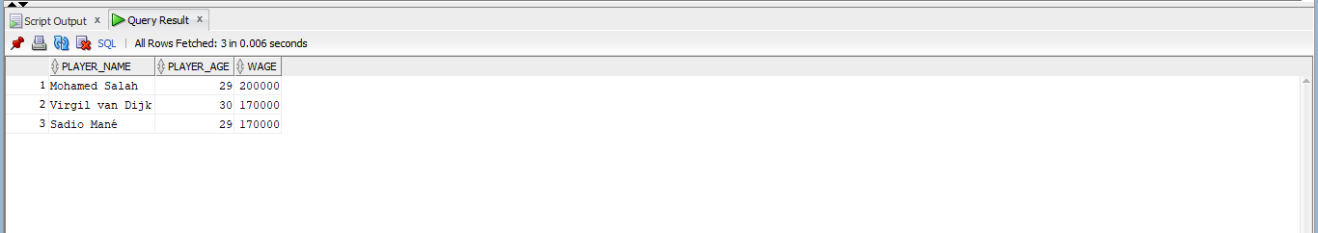SELECT P.PLAYER_NAME, P.PLAYER_AGE, C.WAGE from PLAYER P, CONTRACT C WHERE P.TEAM_ID = 4 AND P.CONTRACT_ID = C.CONTRACT_ID AND C.WAGE > 150000;  **(Auwais)**

### Query 10: Get list of players with no sponsors

SELECT P.PLAYER_NAME, T.TEAM_NAME FROM PLAYER P, TEAM T WHERE P.TEAM_ID = T.TEAM_ID AND P.PLAYER_ID NOT IN (SELECT PLAYER_ID FROM PLAYER_SPONSOR); **(Auwais)**

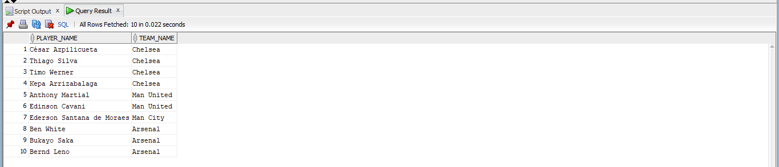

# Conclusion:

The aim of this project was to build a Super Premier league database which consisted data from the top five teams in the country. These aims were met successfully, and a well-designed database has been created and tested. Before the initial implementation of the database such as creating SQL scripts, the list of attributes and **ERD** was key to the development of our database. The mapping of the ERD was very important because it is essential to understand the relations between each entity and attributes. **Normalization** was carried out after creating the ERD, this was very important, eliminating data redundancy and making the database more flexible. **Indexes** was another key aspect in the project, being able to search up data from the database quickly is quite essential and would help users, managers and scouts gather information rather quickly. Overall, the scripts ran with no errors. Tables were dropped, created, and updated successfully and **SQL Queries** ran smoothly collecting data as shown in the report.

# References:

Vincent, J., Stergiou. P. and Katz, L. (2009) The Role of Databases in Sport Science: Current Practice and Future Potential: *International Journal of Computer Science in Sports.* Available at: <https://www.researchgate.net/publication/266455968_The_Role_of_Databases_in_Sport_Science_Current_Practice_and_Future_Potential/> [Accessed 18 July 2021].